FUNDAÇÃO GETULIO VARGAS  
ESCOLA DE ADMINISTRAÇÃO DE EMPRESAS DE SÃO PAULO

**MOBILE MONEY AND WOMEN EMPOWERMENT IN SUB-SAHARAN AFRICA:**

**AN EXPLORATORY STUDY**

JULIETTE CLEMENCE POIRET

SÃO PAULO - SP

2016

JULIETTE CLEMENCE POIRET

**MOBILE MONEY AND WOMEN EMPOWERMENT IN SUB-SAHARAN AFRICA:**

**AN EXPLORATORY STUDY**

Thesis presented to Escola de Administração de Empresas de São Paulo of Fundação Getulio Vargas, as a requirement to obtain the title of Master in International Management (MPGI).

Knowledge Field: Financial Inclusion

Adviser: Prof. Dr. Lauro Emilio Gonzalez Farias

SÃO PAULO - SP

2016

|  |
| --- |
| Poiret, Juliette.  Mobile money and women empowerment in sub-Saharan Africa : an exploratory study /Juliette Poiret. - 2016.  76 f.  Orientador: Lauro Emilio Gonzalez Farias  Dissertação (MPGI) - Escola de Administração de Empresas de São Paulo.  1. Transferência eletrônica de fundos. 2. Sistema de comunicação movél. 3. Mulheres – África Sub-Saara. 4. Microfinanças. 5. Empreendedorismo. 6. Inclusão financeira. I. Curado, Isabela Baleeiro. II. Dissertação (MPGI) - Escola de Administração de Empresas de São Paulo. III. Título.  CDU 336.77(6) |

JULIETTE CLEMENCE POIRET

**MOBILE MONEY AND WOMEN EMPOWERMENT IN SUB-SAHARAN AFRICA:**

**AN EXPLORATORY STUDY**

Thesis presented to Escola de Administração de Empresas de São Paulo of Fundação Getulio Vargas, as a requirement to obtain the title of Master in International Management (MPGI).

Knowledge Field: Financial Inclusion

Approval Date

28/11/2016

Committee members:

________________________________

Prof. Dr. Lauro Emilio Gonzalez Farias

________________________________

Prof. Dr. Adrian Kemmer Cernev

________________________________

Prof. Dr. Tania Pereira Christopoulos

**Acknowledgements**

Firstly, I would like to thank my supervisor Prof. Lauro Emilio Gonzalez for sharing his knowledge on financial inclusion. Other acknowledgments go to Prof. Felipe Zambaldi for his advices on regression analyses, and Magali and Pierre-Antoine, two French PHD students who have also helped me dealing with statistics.

Moreover, I would like to express all my gratitude to my FGV São Paulo and SciencesPo Paris teachers. They taught me that curiosity is key, and helped me strive to do better. During these 5 years of studies, I had the chance to develop a strong interest for international development, and I am now determined to explore it further in my career.

On a more personal basis, I would like to thank my friends in São Paulo and Paris, and my parents, whose pride and support have always given me the willingness to surpass myself.

**Abstract**

This research explores the relationship between the penetration of mobile money services and the state of women empowerment across 30 Sub-Saharan African countries. Our purpose is to determine whether fostering the development of mobile money can be a useful tool to reinforce women empowerment in developing countries. We perform an exploratory data analysis, as well as correlation and regression analyses, to assess the effect of mobile money services on women empowerment. In order to do that, we construct several mobile money variables and a women empowerment index, using national-level data collected through questionnaires addressed by the World Bank on selected samples. Our results show a positive yet moderate relationship, and pave the way for further research on this subject.

**Keywords:** Financial Inclusion, Mobile Money, Women Empowerment

**Resumo**

Esta dissertação analisa a relação entre a expansão dos serviços de *mobile money* e o empoderamento das mulheres na África Subsariana. O propósito é determinar se *mobile money* pode ser um instrumento útil para reforçar o empoderamento das mulheres dos países em desenvolvimento. Realizamos uma análise exploratória dos dados através de correlações e regressões para avaliar o efeito dos serviços de *mobile money* sobre o empoderamento das mulheres. Criamos diversas variáveis associadas os serviços de *mobile money* e um index do empoderamento das mulheres utilizando dados do Banco Mundial. Nossos resultados mostram uma relação positiva mas moderada, preparando caminho para outras pesquisas.

**Palavras-chave:** Inclusão Financeira, *Mobile Money*, Empoderamento das Mulheres

**Tables of Content**

1. Introduction 10

2. Literature Review 12

2.1. Mobile Money 13

2.1.1. The financial inclusion imperative 13

2.1.2. The success of mobile money 14

2.1.3. The effect of mobile money 17

2.1.4. Mobile money and traditional banking 20

2.2. Women Empowerment 22

2.2.1. The importance of women empowerment 22

2.2.2. Definitions of women empowerment 23

2.2.3. Measures of women empowerment 26

2.2.4. Women empowerment and financial inclusion 29

2.3. Mobile Money and Women Empowerment 31

3. Methodology 33

3.1. Research type 34

3.1.1. Research approach and design 34

3.1.2. Research method 35

3.2. Data description 36

3.2.1. Data collection 36

3.2.2. Data selection 37

4. Data Analysis 37

4.1. Variables construction 38

4.2. Exploratory data analysis 41

4.3. Correlation analysis 49

4.4. Regression analysis 50

5. Conclusion 55

Bibliography 58

Appendices 64

**List of tables and graphs**

*Figure 1: Mobile money account ownership (map)* 42

*Figure 2: Basic statistics of mobile account ownership (table)* 42

*Figure 3: Mobile money penetration (graph)* 44

*Figure 4:* *Mobile money penetration for the female population (graph)* 45

*Figure 5: "Mobile account" variable regional split (table)* 45

*Figure 6: Women empowerment index components (graph)* 47

*Figure 7: Women empowerment index (graph)* 48

*Figure 8: Women empowerment index regional split (table)* 48

*Figure 9: Scatterplot - "mobile account female" and women empowerment index* 50

*Figure 10: Predicted versus actual (graph)* 53

*Figure 11: Residuals (graph)* 54

**List of Acronyms and Terms**

ATM: Automated Teller Machine

GDP: Gross Domestic Product

GEM: Gender Empowerment Measure

GPFI: Global Partnership for Financial Inclusion

GNI: Gross National Income

GSMA: Groupe Speciale Mobile Association

HDI: Human Development Index

MNO: Mobile Network Operator

NGO: Non-Governmental Organization

PPP: Purchasing Power Parity

UN: United Nations

UNCDF: United Nations Capital Development Fund

UNDP: United Nations Development Program

UNICEF: United Nations Children's Fund

UNIFEM: United Nations Development Fund for Women

1. Introduction

Financial inclusion tools have received an increasing amount of attention in the past decade due to their positive effects on economic and social development. Various international organizations, especially the World Bank, have acknowledged the crucial importance of providing financial services to the poor and excluded people in developing countries. Along academics and non-profit organizations, private companies have started to focus on the unbanked population and target this untapped market. Mobile money services, including transfer, withdrawal and payment services, allow people to transact easily through their mobile phones, avoiding the frequent geographical or financial barriers. Mobile money operators are acting towards financial inclusion, offering lower fees and no minimum balance. As a consequence, the effect of mobile money services on economic and social development through the channel of financial inclusion has been gradually highlighted in the literature.

At the same time, gender equality and women empowerment have been designated as two of the most urgent development goals for the 21st century by many governments and international organizations. Academics have gradually recognized the positive effect that women empowerment has on development. Thus, finding its determinants remains a crucial research question. The question of the effects brought by financial inclusion initiatives such as microfinance on the empowerment of women in developing countries has been studied intensively in the past few years, and most authors agree today that they are positive. The access to financial services has thus been recognized as one of the elements fostering women empowerment in developing countries.

The role played by mobile money services, as innovative financial inclusion tools, and their effects on women empowerment, have emerged gradually as objects of study. The literature has focused on Sub-Saharan Africa as it is the poorest region on earth, and because the combination of low levels of women empowerment with high mobile money penetration rates can provide very insightful observations. Many authors have conducted qualitative studies to explore the relationship between mobile money and women empowerment, mostly at the community level. Almost all of them focus on M-Pesa in Kenya, as this service has known an extraordinary success in the past decade.

Simultaneously, more data has been gathered on these new providers of financial services. The World Bank has notably completed its Global Findex database in 2014 with information on the use of mobile money services around the world obtained through questionnaires. With these new indicators available for almost every country in the world, researchers are now able to extend their studies beyond the community level. This increasing amount of attention and information on mobile money services in the international development field has led us to the following research question:

**Is there a positive relationship between mobile money services adoption and women empowerment in Sub-Saharan Africa?**

To tackle this problem, we conducted an exploratory study using the quantitative data contained in the 2014 Global Findex database and the Gender Statistics database updated every year by the World Bank. We delimitated our sample to Sub-Saharan Africa, which is the region where mobile money services have known the greatest success, but also where development needs are the most important and gender gaps the widest.

First, we explored the existing literature on mobile money services, women empowerment, and the relationship between both. It enabled us to build a conceptual framework, guiding us in our analysis and helping us determining the variables we needed to select. Then, we conducted an exploratory data analysis, to interpret the information that we had on the penetration of mobile money in Sub-Saharan Africa and on the different levels of women empowerment in this region, and to recognize the main patterns within our dataset. Finally, we conducted correlation and regression analyses to test for the significance and strength of the relationship between mobile money and women empowerment, while controlling for other variables that might have an effect.

This question is important because it allows us to determine whether we can generalize a phenomenon that has been observed within Kenyan communities to broader areas with different economic conditions, geographies, and cultures (language, religions etc.). If yes, more efforts could be done to improve the use by women of mobile money services.

This thesis could be useful to both public sector - governments, non-governmental organizations (NGOs) and international organizations aiming at fostering women empowerment in Africa - and private sector (i.e. the mobile operators and financial institutions seeking to adapt their products to the population needs). On a personal level, this research combines the academic focus I have undertaken on finance and economics in developing countries with my personal interest in international development. I am convinced of the need to achieve greater financial inclusion to eradicate poverty, and therefore I hope that this research can increase knowledge and trigger interest on this topic.

2. Literature Review

## 2.1. Mobile Money

### 2.1.1. The financial inclusion imperative

Overall, there is no universally accepted definition of financial inclusion, but the provision of basic financial services (savings, credit, means of payments and insurance) is the most important requirement. It is opposed to financial exclusion, which is “a process whereby people encounter difficulties accessing and using financial services and products (…) that are appropriate to their needs and enable them to lead a normal social life in the society to which they belong to” (European Commission, 2008).

The World Bank (2015b) notes that 73 percent of the world’s poor population does not have access to the financial system, including more than 50 percent of the adults in the poorest 40 percent of households in developing countries. While the developed countries have a 94 percent rate of banked population, the proportion in the developing world is only 54 percent (EY, 2015). The unbanked population constitutes “a minority of predominantly vulnerable and otherwise disadvantaged people” (Kempson and Whyley, 1999), mostly women, youth, rural and the poor (EY, 2015). According to Rahim et al. (2009), barriers to financial inclusion exist at the demand (users) and supply (providers) sides (Rahim et al., 2009). Demand side factors can be a lack of excess money to save, the fees involved by owning an account, the lack of trust in formal institutions (Van der Werff, Hogarth and Peach, 2013), but also financial illiteracy (i.e. the lack of knowledge of financial products and services). Supply side factors can refer to a lack of investment in bank branches or high transaction costs for example. To sum up, there is a lack of proper services, that is, those that meet the needs of the poor.

The importance of financial inclusion for development and poverty alleviation has been largely emphasized in the literature. Poverty is not just a lack of money but also a lack of access to the instruments that could improve living conditions. This problem has been identified as one of the key barrier to development, at the household level but also for businesses which face several constraints to financing. Even when accessing informal financial services, poor people cannot save, borrow and manage risk as effectively as in the formal financial system. Demirgüç-Kunt, Beck, and Honahan (2008) stress that these constraints restrain economic growth and worsen inequalities. Expanding access to financial services is thus crucial for developing countries, precisely where mobile money providers have started to operate.

Financial inclusion is also closely linked to the development of the financial sector. Todaro and Smith (2011) highlight the benefits brought by a well-functioning financial sector to a country, such as “providing payment services, matching savers and investors, generating and distributing information, allocating credit efficiently etc.”. Slower growth in low to middle-income countries can be explained by the absence of several crucial functions, a lack of regulation by the authorities, or the lack of inclusion of the poorest that we have seen previously.

The definitions of financial inclusion usually exclude mobile money account ownership, as it does not give access to the full range of traditional banking services. For example, according to the Reserve Bank of India (2011), financial inclusion is the process of “ensuring access to appropriate financial products and services needed by vulnerable groups at an affordable cost in a fair and transparent manner by mainstream institutional player”. Mobile money operators are not considered as mainstream players. Most of the measurements of financial inclusion only include the products and services provided by formal and traditional banking institutions as mobile money providers are not registered as banks and thus cannot offer interest-bearing savings accounts to their customers (national regulations often impose that the e-float has to be backed 100 percent by deposits).

However, mobile money is considered as an innovative tool to extend financial access to the poor and drive financial inclusion. The Global Findex database elaborated by the World Bank (2014) even defines being banked as “having an account either at a financial institution or through a mobile money provider”. Through a mobile money account, one can have an active financial life by depositing and transferring money, saving, paying bills etc. Thus, we consider mobile money services as proper financial services and include them in the spectrum of solutions available to deepen financial inclusion over the world.

### 2.1.2. The success of mobile money

According to the World Bank (2015a), mobile money is an “e-money product where the record of funds is stored on the mobile phone or a central computer system, and which can be drawn down through specific payment instructions to be issued from the bearers’ mobile phone”. It is different from mobile banking services, through which “a bank’s clients connect to their accounts at the bank via their mobile device” (AFI, 2010). Mobile banking implies having an account at a bank or another type of financial institution (credit union, cooperative, microfinance institution).

Mobile money accounts, also known as mobile payment services, are not offered by financial institutions, but usually telecom providers. They are limited to services that can be used without a bank account (i.e. money transfers, deposits and withdrawals), but they also serve as a platform for additional uses such as paying bills, purchasing goods and services, receiving salaries and conditional cash transfers, repaying microcredit, purchasing insurance etc. Although the mobile phone is necessary to use these services, a cash-in cash-out infrastructure is needed (i.e. a network of agents who turn cash into electronic value for a small commission).

Mobile money is now being adopted by more and more people, and across many different sectors such as commerce, agriculture etc. According to the GSM Association (GSMA), around 255 mobile money services are now operating across 89 countries, and mobile money accounts are available in 61 percent of developing countries (GSMA, 2014). There are around 300 million people currently using mobile money as their sole formal account, and one third of them are from Sub-Saharan Africa.

The existing literature highlights three main factors explaining the recent success of mobile money services: the persistent lack of access to financial services in low-income countries, the simultaneous expansion of mobile penetration and cellular coverage to remote areas, as well as the increasing need to provide cheap and safe financial services to the unbanked population.

Firstly, the number of automated teller machines (ATMs) and bank branches is very low in most of the low to middle-income countries in comparison to developed countries, whereas cellular coverage is almost the same (Kpodar and Andrianaivo, 2011). In these countries, it is often not profitable for financial institutions to expand their traditional infrastructure beyond major cities. According to KPMG (2015), margins of brick and mortar businesses are too low in remote areas because of high transaction costs, distribution challenges, a lack of awareness of financial products, and a lack of skilled workforce (especially in IT). Also, the lower ticket size of transactions in these areas is not suitable for conventional banking services. This lack of financial infrastructure and access leaves "certain geographic areas and customer segments unserved or underserved” (GPFI, 2015).

Mobile money’s success is also directly linked to the explosive growth in cell phone access and cellular coverage in developing countries. The G20 Global Partnership for Financial Inclusion (GPFI) has declared that in 2015, there has been 7.5 billion mobile phone subscriptions globally, up from 6.3 billion in 2012 (GPFI, 2015), surpassing the global population. Smartphone penetration is still increasing and is projected at 50 percent by 2020, according to KPMG (2015). Tobbin (2012) observes that “within the developing world, many rural people are deprived of basic services such as water, electricity and banking, and yet still have access to a mobile phone, the number of which has exceeded people with bank accounts”. This mobile revolution has changed the life of many people living in rural areas, characterized by low population density and poor transportation infrastructure. According to the economist Sachs, “the cell phone is the single most transformative technology for development” (Voigt, 2011). More precisely, it is not the cell phone itself that is changing the developing world but the additional technologies that have emerged out of it. The network coverage has also expanded and reached most of the world’s remote areas in the past decade, although it is still far from being complete. Research by the Evans School of Policy Analysis and Research at the University of Washington found that 11.7 percent of the world’s population lived without mobile coverage in 2012, and over nine in ten of these people lived in rural areas (Biscaye et al., 2015). Several government initiatives have thus attempted to solve this problem through operator license issuances and minimum network coverage standards.

Thirdly, there has been an increasing need for low-cost financial services in the developing world. Mobile money accounts offer reasonable service fees, the ability to deposit and withdrawal money at convenient locations, and to do person-to-person money transfers. Lower fees are translated into more money sent through remittances. Also, the devices are generally easy to use, and there are many agents available, even in remote areas. Finally, minimum balance requirements are really low. This element is crucial to reach the unbanked population, because even if poor people had physical access to a bank, most of them would not have enough money to reach the minimum balances required. These lower prices are derived from the low cost structure of mobile money operators. Mobile Network Operators (MNOs) use their existing infrastructure to provide mobile money services, and it is certain that they do not have the same rental and labor costs as traditional banks.

The excitement around mobile money has arisen thanks to its effectiveness in providing financial access to the poor and excluded people around the world. This highlights the fact that financial inclusion has been part of the mobile money providers’ strategy since the beginning. But mobile money is also a very scalable and profitable business model through volume, speed and coverage. It demonstrates the “profitability of low-income markets” (Prahalad, 2006).

It is in Africa, where the financial infrastructure gap is the largest, that mobile money services have known the greatest success. Prior to their introduction, most Africans did not have any access to formal financial services. Beck (2007) observes that prior to the introduction of mobile money accounts, African countries were lagging behind in terms of financial access, with only 1.6 bank branches per 100,000 people in Ghana, 1.3 in Kenya, and less than 0.6 in Uganda and Tanzania. The ATM access was even worse, with only 1 per 100,000 in Kenya and less than 0.2 in Tanzania. As a result, the average proportion of people owning a bank account in Southern and East Africa was stagnating at 30 percent (FinMark Trust, 2008). In parallel, there has been growing penetration of cell phones and an extension of cellular coverage over the African continent. In 2015, there were over 900 million mobile subscribers in Africa (Forbes, 2015).

Acknowledging these particularly low levels of financial access and high levels of mobile penetration, MNOs have grasped the opportunity to expand the reach of the financial system through mobile money services. Today, on the top 20 countries in the world for mobile money usage, 15 are in Africa. Usage grew 400 percent from 2005 to 2010, due to the decreasing price of cell phones (Voigt, 2011). In Sub-Saharan Africa, around 12 percent of the population own mobile money accounts, compared to a 1 percent average worldwide (EY, 2015). In Kenya, two thirds of all adults are active customers of mobile money providers, half in Tanzania.

Companies such as M-Pesa in Kenya, MTN Mobile Money in South Africa or Orange Money in West Africa, have thus succeeded in reaching the unbanked population. M-Pesa, the global leader, is operating in 6 African countries and has more than 20 million users (Donovan, 2012). In 2013, 43 percent of Kenya’s gross domestic product (GDP) was circulating through M-Pesa, with over 237 million person-to-person transfers. M-Pesa users living with less than $1.25 per day increased from 20 percent in 2008 to 72 percent by 2011 (Forbes, 2015).

Asia and Latin America have also known a few success stories, but to a lesser extent. Smart was the first operator to perform person-to-person transfers in 2000, making the Philippines a global leader in mobile transactions. bKash in Bangladesh, with a 80 percent market share nationally, is becoming one of global leaders in mobile money. And EasyPaisa, launched in 2009 in Pakistan, is now the third largest mobile money provider in the world with around 7.4 million users (Forbes, 2015).

It is important to note that the popularity and success of mobile money services are not homogenous across countries (Heyer and Mas, 2009), especially within Sub-Saharan Africa. Different factors explain these variations, such as the regulatory environment (know your customer procedures, security and consumer protection, agent and bank licensing regulations, interoperability rules etc.), the retail landscape (and notably airtime re-seller network), the cellular market landscape (mobile penetration, network coverage, market shares of the MNOs), and other country-level factors (business environment, political risk, socio-demographic factors etc.). There are also various drawbacks to the use of mobile money accounts that constitute a brake to their expansion, that is, the limited access to the full range of financial services (including loans) and the higher risks induced by softer regulation (such as money laundering).

### 2.1.3. The effects of mobile money services

Support for mobile money services from governments, international organizations and NGOs has been accompanied by impact assessments and monitoring. An expanding literature has assessed the effect of mobile money services, and especially money transfers, deposits and withdrawals, on transaction patterns and welfare of the target populations.

To determine the usage and the effect of mobile money, most of the authors we reviewed have focused on M-Pesa in Kenya, as it has known the greatest success among all other services. In Kenya, the areas in need of mobile money services are split across both urban (deposit) and rural (withdrawal). While trying to create the customer profile of a typical M-Pesa user in Kenya, Budree and Williams (2013) distinguish two main categories of users: the “youth” group (composed of unemployed persons or students, receiving money for transport, food and clothing), and the “migrant labor” group (full-time employed persons, urban, sending money to support family in remote areas).

Plyler, Haas and Nagarajan (2010) focus on the community-level economic effects of M-Pesa in Kenya. They try to understand its direct and indirect effects on users and non-users within given communities. They carried out fieldwork and qualitative data gathering in three districts, all different in terms of rural and urban population proportion and number of M-Pesa agents. Four economic direct and spillover effects were ranked by order of importance: a local economic expansion (increase in money circulation, expansion of businesses and local employment), a higher security (physical, financial and food), and capital accumulation (financial, human and social), a better business environment (ease of transactions and quality control). The most important sub-effect was an increase in money circulation, due to “a greater volume of money flowing into and out of the communities and a faster flow of money within the community to boost local consumption”. Increased remittances, by putting more cash into people’s pockets, would increase the amount of money spent into the community and thus local economy. Transactions ease was the second biggest sub-effect identified by participants. Lower transaction costs have expanded financial participation among community members, by increasing the number and volume of transactions. Money security and privacy, in terms of the ability to accumulate cash and control spending, was also a very important consequence. Food security, in terms of higher agricultural productivity, and better access to various quality food products, was also mentioned frequently. Fast money transfers to buy seeds when needed or hire temporal labor facilitated the processes, and the time saved from going to the bank and queuing was instead used for farming. Facilitated human capital accumulation was finally the last sub-effect of the top five. Participants remarked that M-Pesa has helped them paying for school fees or medical expenses, which seemed to have consequences on school attendance and medical consultations.

Other important effects were also remarked, at a lesser extent. Increase in local employment was noticed by the communities, mostly directly referencing to M-Pesa shops openings. In Muranga for example, a M-Pesa shop owner declared having been able to expand from 3 to 22 shops, thus creating many jobs in his community. M-Pesa also allowed an expansion of businesses. In Kitui, an agent said that in the shopping mall where she operates, she has seen more meat vendors and bars after the implementation of M-Pesa. Physical security has also been noticed, implying a decrease in theft, pickpocketing and mugging, especially compared to minibuses cash transfers. It was observed that most of these elements had spillover effects. For example, the increase in money circulation also affects expansion of businesses, food security and human capital accumulation. Physical and money security also benefited the expansion of businesses.

The magnitude of these effects was determined by gender and geographic location of the communities. For example, the importance of the increase in money circulation varied by gender, with men ranking it number one and women number three. Also, people in rural areas considered food security as a more important sub-effect that those living in urban areas, and rural women insisted more on this effect than rural men. Thus, generic conclusions assessing the community-level effects of M-Pesa could not be deducted, showing the crucial importance of cultural and geographical differences.

The local economic expansion effect has been noted by other authors. The increase in transfers and payments, and thus in money circulation, has been particularly stressed in the literature. The speed and liquidity of mobile money (compared to other assets such as livestock or gold) is a crucial point. M-Pesa is a useful way to access cash, especially since poor people tend to lack fungible sources of exchange. “Through the network of cash agents and people’s contacts willing to send value, mobile money allows many to get cash when and where they need it” (Stuart and Cohen, 2011). But it also reduces the overall importance of cash, which “cuts down on corruption (…) empowers individuals, and supports entrepreneurial creativity in a less constrained financial marketplace” (Forbes, 2015). Mbiti and Weil (2014) find that M-Pesa improves individual outcomes, by increasing transfers (almost 35 percent of interrogated people have increased their frequency of sending transfers, while 31 percent have increased their frequency of receiving money), and reducing the use of informal savings mechanisms such as rotating savings and credit associations (by 30 percent).

In comparison, business creations and job opportunities surrounding the emergence of mobile money services have not been explored substantially, whereas it has been observed that “many small companies rely on M-Pesa for nearly all transactions, or provide a service that is a derivative of the platform itself” (Forbes, 2015). Mobile money services directed towards businesses do exist, but they are not highlighted in the literature.

The higher security and capital accumulation has also been studied substantially, with many authors insisting on security and safety improvements (such as a lower risk of muggings and theft), more privacy and autonomy in managing incomes, and a higher resistance to negative shocks (such as deaths, harvests problems or job losses).

Heyer and Mas (2009) say that “mobile money should increase convenience by reducing travelling time, increase safety of transactions to users, and greater control on where to transact through a large footprint of agents and outlets, which helps protect privacy and reduce corruption”.

Jack and Suri (2011) show that mobile money improves the ability of the poor people to smooth risks. From the data collected, households who were using mobile money were better able to absorb negative shocks than those who did not (the latter saw their consumption falling by 6 to 10 points of percentage in such cases), as they were receiving more remittances in terms of frequency and amount, and lost less money due to transaction costs (formal or informal). Remittances now cover “larger segments of Kenya’s population in terms of income, age and depth and breadth of access” (Jack and Suri, 2011). Morawczynski (2009) noticed the same pattern during the violent period following the 2007 election in Kenya, when M-Pesa was the only mean through which the population of Kibera settlement could access cash.

The overall positive effect of the expansion of mobile money on the lives of people, urban or rural, poor or middle-income, men and women, has been largely stressed in the literature. The ability of mobile money to foster the access to traditional banking services has also been frequently highlighted. Mobile money services would thus have a direct effect on the lives of people as seen previously, combined with an indirect effect channeling through an increased access to more elaborated financial products such as savings and loans.

### 2.1.4. Mobile money and traditional banking

The first question addressed by different authors is whether mobile money usages can be compared to formal banking's. The second is whether owning a mobile money account is a stepping stone towards the ownership of a bank account at a traditional financial institution.

Morawczynski (2007) tries to understand M-Pesa users through 350 semi-structured and 21 group interviews in Kibera and a village in the western part of Kenya. Apart from transferring money to relatives, M-Pesa users also acknowledged diversifying the location of their deposits. Following the same logic, Morawczynski and Pickens (2009) treat ethnographic evidence to show that M-Pesa has changed savings behaviors, and that it is partially used as a saving instrument. Thus, they conclude that M-Pesa is a partial substitute for the banking system, and the most efficient way of providing financial services to the poor.

Jack and Suri (2011) conduct an empirical and quantitative study showing that people use M-Pesa to save money. They randomly select 3000 households across Kenya and find that even if the main purpose remains the sending of remittances at a lower cost, 21 percent see M-Pesa savings as their most important saving instruments and 90 percent as one of the three most important.

Mbiti and Weil (2014) examine the utilization of M-Pesa at the individual level, using micro-level FinAccess surveys, transaction data from M-Pesa agents, and aggregate data from Safaricom and the Central Bank of Kenya. Their research aims at determining whether M-Pesa is only another money transfer system or a new mean of saving money and providing financial services to the unbanked population. They want to understand whether it is more a deposit-transfer-withdraw type of service, which would not be economically important, or a new saving tool. They compute the velocity of the service at four person-to-person per month, and observe that e-float balances are usually held for long periods of time, which constitute some of the aspects of traditional banking uses.

Most of the authors agree that mobile money uses can be compared to some of the traditional banking services. Mobile money is not just another type of money transfer service, but a real mean to provide financial services to the poor. “Where most financial inclusion models have employed either ‘credit-led’ or ‘savings-led’ approaches, the M-Pesa experience suggests that there may be a third approach – focusing on building the payment ‘rails’ on which a broader set of financial services can ride” (Mas and Radcliffe, 2010).

However, it cannot be seen as a substitute for the banking system, nor as a stand-alone product, but more as a complementary tool. Mobile money providers cannot offer the same range of services that banks do.

Owning a mobile money account seems to be a first step towards entering the formal banking system. Mbiti and Weil (2014) provide quantitative evidence of M-Pesa’s ability to increase the probability of being banked (at a financial institution). They use regressions to show that there is a strong and positive relation between M-Pesa penetration and bank use, formal savings and employment. With a current adoption rate of 40 percent, M-Pesa has raised the percentage of banked population by almost 11 points, a 58 percent increase from 2006. This result can be explained by an increase in money in circulation, and the complementarity between M-Pesa and Kenyan banks.

Mobile money is thus “an option for the unbanked to be able to enter the banked fold” (Budree and Williams, 2013). People who are used to deal with deposits and e-float are more likely to open bank accounts afterwards as they have more trust in the financial system. Once access is gained to the financial system, mobile money is not dismissed but used for storing small amounts and transferring money, while bank accounts are used for long-term savings (White, 2012). Having a mobile money account is thus “a pathway to a broader range of responsible financial services provided through stronger and more diverse financial institutions” (World Bank, 2015).

It is worth noting that MNOs are increasingly partnering with financial institutions in order to offer the services that are missing from their offers: insurance, credit, and savings (which, added to the means of payments, constitute the four elements found in the financial inclusion definition).

According to GSMA’s 2014 State of the Industry report, over 10 million mobile savings accounts have been created through 26 bank-MNO partnerships in 22 countries (GSMA, 2015). Banks now allow their customer to link their bank accounts with their mobile money accounts. For example, Safaricom and Equity Bank have introduced M-Kesho in Kenya, an interest-bearing savings service directly linked to an M-Pesa account. A micro-insurance product named Kilimo has also been developed with M-Pesa, to deliver payouts to farmers whose crops fail. According to Sen and Choudhary (2011), “in its second year of operation, 12,000 farmers were insured, and 10 percent of those received payouts of up to 50 percent of their insured inputs”. These services allow companies to collect data on their customers, analyze their financial histories and assign them credit scores, increasing the ability to expand credit to the poor and excluded population.

Governments also start to use mobile money, notably for salary disbursements and conditional cash transfers, which improves their ability to manage cash flows, collect tax, and monitor illicit activity. In Afghanistan, the telecom company Roshan launched M-Paisa in 2009 in collaboration with Vodafone and the Ministry of the Interior to pay police salaries through mobile money accounts. According to Forbes (2015), “costs dropped by 10 percent as phantom payments to nonexistent police officers were eliminated and corruption was reduced”. A study by McKinsey for the Bill & Melinda Gates Foundation affirms that “connecting poor households to an electronic payment system for cash transfers would have considerable effect through reduced leakages, transaction costs, and overheads” (Lochan et al., 2010). Closer collaboration between MNOs, banks and governments is needed to expand the reach and effectiveness of mobile money services, and thus driving financial inclusion in the most remote areas of the world.

## 2.2. Women Empowerment

### 2.2.1. The importance of women empowerment

According to United Nations Development Program (UNDP), “there are still large inequalities between men and women which make women more vulnerable to poverty (…) and prohibit women from participating in economic, social, and political life” (UNDP, 2014). Women are disproportionally represented among the poorest people in most of low to middle-income countries. Baden and Milward (1995) state that “although women are not always poorer than men, because of the weaker basis of their entitlements, they are generally more vulnerable and, once poor, may have less options in terms of escape”. Women consistently face serious disadvantages compared to men such as limited business opportunities, lower employment rates and wages, an overwhelming domestic burden, low self-confidence and self-esteem, low education and literacy, restrictive legal frameworks, a lack of representation and participation in private and public decision-making etc.

Global development institutions promote women empowerment for two reasons. The first one is that women empowerment is intrinsically worth achieving, as social justice is a fundamental human right and a critical component of human welfare. The second reason is that empowering women is a mean to reach other development outcomes. Women empowerment is indeed recognized as one of the most crucial factors for economic and social development, improving not only women’s quality of life but the welfare of men, families, and communities (UN Women, 2011).

The World Bank (2001) stresses that countries with important gender discriminations “pay the cost of greater poverty, slower economic growth, weaker governance, and a lower living standard of their people”. Women empowerment “can lead to higher growth” (Todaro and Smith, 2011), and "is a prerequisite for achieving political, social, economic, cultural, and environmental security among all peoples” (UN Women, 1995). According to the United Nations (UN), “providing women and girls with equal access to education, health care, decent work, and representation in political and economic decision-making processes will fuel sustainable economies and benefit societies and humanity at large” (UN, 2015). The encouragement of women participation in all sectors of the economy is thus very important for building strong economies and stable societies. It is a crucial element of any development strategy, and is currently on the agenda of major development organizations. The UN has stressed the importance of promoting gender equality and empowering women, ranking it as the fifth priority of its Sustainable Development Goals (UN, 2015). Developing countries have made a great progress in the past decades to promote women empowerment, and they have sometimes surpassed developed countries in ratifying conventions promoting gender equality (Cheston and Kuhn, 2002). For example, two thirds of them have achieved gender parity in primary education in only two decades.

### 2.2.2. Definitions of women empowerment

Research on gender issues has been developed intensively in the past decades, across different fields (such as anthropology, sociology or economics), using both qualitative and empirical analyses. Women empowerment is a concept that has emerged gradually, leading to different definitions and interpretations. Definitions and measurements of women empowerment have been subject to intense discussions and debates. The uncertainty around this concept is linked to two main factors. Firstly, women are not a homogenous group, but more a “cross-cutting category of individuals that overlaps with all the other disempowered groups (the poor, ethnic minorities etc.)” (Kabeer, 2001). Second, we are still not sure about what empowerment really means, as “it can mean different things in different social contexts” (Hashemi et al., 2006), and in different geographical, cultural and religious settings.

There is a growing body of literature aiming at defining empowerment, and an emerging consensus on how we should conceptualize and operationalize it. The World Bank (2001) defines empowerment as the process of “enhancing the capacity of individuals and groups to choices and to transform those choices into desired actions and outcomes”, breaking down the concept into two key components: the agency (the ability to choose) and the opportunity structure (the context affecting the extent to which one can transform his choices into effective action). According to the United Nations Development Fund for Women (UNIFEM), empowerment is about “gaining the ability to generate choices and exercise bargaining power” (UNIFEM, 2000).

As for women empowerment, Kabeer (2001) offers one of the most practical definitions, as it can be applied in very different contexts. She states that it relates to “the expansion in people’s ability to make strategic life choices in a context where this ability was previously denied to them”. Two crucial elements are highlighted in this definition: the notion of process and the notion of agency (choices are made among real alternatives). This process of change, from a state of disempowerment to an ability to take decisions, is what distinguishes women empowerment from gender equality. It was previously highlighted by Sen (1993), whose definition of empowerment involves “altering relations of power, which constrain women’s options and autonomy and adversely affect health and well-being”, and by Keller and Mbwewe (1995) who stress “a process whereby women become able to organize themselves to increase their own self-reliance, to assert their independent right to make choices and to control resources which will assist in challenging and eliminating their own subordination”. Frequent references to change, power, well-being, freedom and choice (as having the possibility of alternatives), are central to the concept of empowerment.

When defining women empowerment, Cheston and Kuhn (2002) observe some common actions such as “an increased participation in decision-making, a more equitable status of women in the family and community, an increased political power and rights, and an increased self-esteem”. These changes are considered to be relevant proofs of women empowerment, even across different cultures. Decision-making, as women’s ability to make life-changing decisions, is crucial to the notion of empowerment. Self-confidence, or women’s perception of their abilities and actual skills, is also very important, even if harder to measure. It is directly linked to the concept of self-esteem. Women’s status in the family is another important aspect to take into account, especially in poor communities where men’s domination is the strongest. For example, participation in income-generating activities increases women’s weight and influence over the strategic decisions taken within the family. Family relationships are also generally improved when each member contributes effectively to the common welfare. Following the same logic, a change in women’s status within the community is also a proof of empowerment. Women’s new financial contribution makes them respected members in their community. Their successes in business are often very visible, giving them greater legitimacy in the community. Finally, women’s empowerment is also about gaining access to political power and rights at the society level, and about being able to select the policies that will affect their lives.

The literature has often tried to break down the concept of women empowerment into key components, and an important work has been already done in developing the resulting frameworks. Chen (1992) observes different components such as “resources, perceptions, relationships, and power”. The United Nations Children's Fund (UNICEF) stresses “welfare, access to resources, awareness-raising, participation, and control” (UNICEF, 1994). But overall, the most frequent frameworks are induced from the distinction between resources, agency, and outcomes (even under other names such as awareness or power). Focusing on women, Malhotra et al. (2002) insist on the importance of separating the different components of the process into resources, agency and outcomes. Resources are the pre-conditions of empowerment, or the enabling factors. In order for a woman to make strategic choices, she needs to have access to the adequate material, human, and social resources (credit, property, education etc.). Agency is the process of decision-making as we have previously stated, and the ability to formulate strategic choices that affect women’s lives. Achievement, outcomes or welfare (UNICEF, 1994) constitute the resulting well-being that can be measured (political participation, economic security etc.). It is sometimes hard to define if an improvement is a resource or an outcome for the empowerment process, as “an increase in women ownership of assets can for example be seen as both a step in empowering women, i.e. a resource, but also as one of the goals of the process” (Malhotra et al., 2002). It is important to keep in mind that resources and outcomes do not constitute empowerment per se in the context of evaluation, whereas agency is considered as the essence of the process. Accessing resources does not necessarily mean being able to use them for a chosen purpose and be empowered. “Women who have been excluded from decision-making most of their lives, and where traditions and norms control the society might find it difficult to use the provided resources in an effective way” (Cheston and Kuhn, 2002). Women must be able to use the resources to reach their goals, using negotiation or manipulation. They need a sense of agency to define their needs and to take effective actions to fulfill them. But these goals are influenced by cultural and social factors, which usually tend to replicate the structures of injustice.

Women empowerment is a bottom-up process initiated by both individuals and groups (Reeves and Baden, 2000). As choices are influenced by the community, the level of individual empowerment can be limited if women as a group are disempowered. Looking at the family and community levels is thus crucial and often sheds light on the reasons why women are disempowered. Kabeer (2001) says that “household and interfamilial relations are a central locus of women’s disempowerment in a way that is not true for other disadvantaged groups”. Social and cultural norms within the community also constrain women empowerment, particularly in terms of gender roles and expectations.

Furthermore, Bennett (2002) highlights the importance of taking into account changes at the society and institutional levels, distinguishing empowerment (“the enhancement of assets and capabilities of diverse individuals and group to engage, influence and hold accountable the institutions which affect them”) and social inclusion (“the removal of institutional barriers and the enhancement of incentives to increase the access of diverse individuals and groups to assets and development opportunities”). Thus, empowerment, which requires agency, would come from below (individuals and communities), whereas social inclusion starts from above and involves systemic change (societies and institutions). Thus, it is through social inclusion that empowerment can be sustained over time. Kabeer (2001) states that “individual women may challenge structural inequalities when they act in ways inconsistent with gender norms, but that the effect of such actions tends to be limited”, as women empowerment “requires collective action in the public sphere”.

To sum up, individual empowerment and success stories can have a great effect on women’s status and rights as a group, and can help leading broad social change. But movements to empower women within a community or a society also increase the opportunities and the status of individual women. These processes are mutually reinforcing, and thus can translate into a virtuous circle when promoting empowerment.

### 2.2.3. Measures of women empowerment

A number of empirical studies have attempted to measure various dimensions of women empowerment, either at the outcome of interest or as the intermediary factor affecting other development outcomes. For now, no major development agency has imposed a unique and rigorous method to evaluate empowerment, and there has been a broad tendency of using this term loosely. But the frameworks that we can find in the existing literature provide a suitable roadmap for measuring women empowerment. Such evaluation methods are crucial to assess the efficiency of the efforts deployed to empower women.

Several authors have indeed developed indicators for evaluating empowerment, based on the key components found in the conceptual frameworks previously mentioned. Kishor (2000) distinguishes three categories of indicators to measure empowerment: direct evidence of empowerment (with data on domestic violence, belief in daughters education, sharing decision-making, equality of grounds reported for divorce, earnings as a share of family income), sources of empowerment (assets owned by women, women education and literacy, employment), and settings for empowerment (ability to choose one’s husband, family structure). Malhotra et al. (2002) summarize the commonly established frameworks, which assume that empowerment mostly occurs along various dimensions (economic, socio-cultural, familial and interpersonal, legal, political and psychological), at various levels (household, community and broader arenas such as regional, national, or global levels). For each of these dimensions, a range of sub-domains are analyzed. For example, pertinent sub-domains for the economic dimension would be the women’s contribution to the family income at the household level, women’s access to credit and markets at the community level, and women’s representation in high paying jobs at the broader levels (see appendix 1).

However, it is important to understand that separating the different dimensions of empowerment and developing practical indicators is not as easy as conceptualizing them. Most of the empirical studies we have read do not operationalize the consensual definitions and frameworks found in the literature, and they do not actually measure the process aspect of empowerment. The complexities of measuring a process must be highlighted here, and many of empowerment measures that have been developed display some conceptual errors.

Individual and household-level studies have made progress in applying conceptual frameworks and effectively capturing aspects of agency, although it is still far from optimal. Malhotra et al. (2002) state that the most frequently used indicators for individual or household levels measurement are the control over resources and the domestic decision-making. Sometimes they merge since control over resources can be used to assess decision-making. Domestic decision-making can be evaluated using financial matters (resource allocation, spending and expenditures) or social ones (children well-being such as education and health). Control over resources can be assessed by the access to resources, control of cash, household budget, participation in paid employment etc. There are also less frequently used indicators such as economic contribution to household, division of domestic labor, business knowledge, participation in political and community actions, marriage and social setting (social status of family, assets brought to marriage, choice of choosing a husband/spouse), couple interaction (communication and negotiation), appreciation within the household and self-esteem. These measures correspond to the separation between resources and agency stressed in the conceptual literature.

Empirical measurement of women empowerment at the community and broader levels has not developed substantially (Malhotra et al., 2002). A few studies use multi-level analyses of empowerment, gathering individual and household data as well as community, regional or national-level information. But most of them display important methodological problems. Indicators used at these aggregate-levels are generally less accurate. Most of them tend to focus on labor market indexes (female/male ratios in the labor force, in managing positions, differences in wages etc.), education (female literacy, enrollment in secondary school), system of marriage, social norms and practices, health, political and legal (see appendix 2). But they are often chosen arbitrarily more than according to the conceptual frameworks, and they do not really measure agency. For example, women’s employment rate does not automatically capture empowerment and the ability to exercise agency. The same case is made for legal rights, which do not necessarily imply an ability to exercise these rights. Kabeer (2001) highlights the fact that there is an important gap between de jure rights to land ownership and de facto rights. Measuring agency at a macro perspective is thus very difficult, implying the use of proxies such as education and employment (Kishor, 2000). As a consequence, frequently used indicators at the aggregate level tend to focus on resources and outcomes, which make empirical studies less accurate. There is finally a lack of adequate gender data at the aggregate-level for most of the low to middle-income countries (even on proxies).

The World Bank (2007) has developed a learning module to use the empowerment concept in a development practice, which seems to be the most suitable framework for measuring empowerment. The model presented can be applied to both action and analysis purposes. Empowerment is measured in different domains (state, market, society) and subdomains of a women’s life, at different levels (local, intermediary, macro). At the intersection of these domains and levels, women display the following degrees of empowerment: the existence of choice (the opportunity to choose actually exists), the use of choice (the opportunity to choose is used) and the achievement of choice (the choice results in the desired outcome). Degrees of empowerment can be assessed by direct indicators, but also by indirect indicators as it is a function of how a women’s agency interacts with the opportunity structure. To measure agency, women’s resources or “endowments of assets” need to be assessed (even if we have previously said that it is more a proxy measure than the true reflection of the agency process). Different types of assets must be quantified: informational, organizational, material, social, financial, human and even psychological ones such as self-confidence. The ability to transform assets and choices into desired outcomes depends on the opportunity structure, i.e. the context of formal and informal institutions (the regulatory frameworks as well as the norms and values that prevail in a specific context). While offering a consistent tool for measuring empowerment, the resulting empowerment matrix is very flexible, allowing authors to identify and select the indicators that are relevant for their research without prescribing the exact data required (see appendix 3 and 3 bis). It allows them to adapt the indicators used to the context of their research, which is crucial as “the capacity of actors to make effective choices varies according to the context in which they operate” (World Bank, 2007). Certain specific situations will only require the use of only some of the elements provided by the matrix, i.e. a few sub-domains and levels.

However, the fact that indicators and indexes such as the Gender Empowerment Measure (GEM) summarize a lot of information into a single number can be seen as contradictory with the multidimensional nature of the empowerment process. The concept of agency is in essence not suitable for measurement as it is supposed to be unpredictable. The empirical tools used to measure it are designed to measure state of being and not moving targets. Measuring and prescribing women empowerment is “violating its essence which is to enhance women’s capacity for self-determination” (Kabeer, 2001). Moreover, applying indicators across cultures can be problematic as empowerment is context-specific. Researchers often make assumptions about what this information actually means, reflecting more their own learnings and values than the reality. Thus, they must be used with great care and cross-checked, using additional data and triangulation.

The literature provides us with guidelines for choosing empowerment indicators more than strict rules. Firstly, the learning module offered by the World Bank (2007) indicates several principles that must be respected in order to deliver an accurate analysis: meaning (to understand both the direction and magnitude of a change), causality (between a development interventions and outcomes) and comparability (across populations and countries). Also, Malhotra et al. (2002) say that “measures of empowerment must involve standards that lie outside localized gender systems and a recognition of universal elements of gender subordination”. Women empowerment can only be understood within a specific context (socio-cultural, economic and political), but its measurement has to be consistent with international conventions and universal human rights. Multiple sources of information are also needed to escape possible interpretative biases. Finally, evaluating clusters of data on a specific dimension of empowerment across several points of time instead of relying on a single indicator for each dimension, will allow researchers to be more precise about women’s agency and its evolution over time (Malhotra et al., 2002).

### 2.2.4. Women empowerment and financial inclusion

As the importance of women empowerment has increased, an important part of the literature has focused on the role played by financial inclusion. It has been gradually recognized that access to financial services is a substantial part of women empowerment, both at the individual and community levels.

Women do not have the same access to financial services than men, especially in developing countries. In Sub-Saharan Africa, the 2014 Global Findex database indicates that only 30 percent of women owned a bank account compared to 39 percent of men. This 9 percent gap has remained stable in the developing world in the past years. Women are being consistently refused access to basic financial services such as transfers, bill payments, savings, loans etc.

The existing literature mentions the channels through which financial inclusion can empower women. Financial inclusion is indeed not only a mean for achieving economic growth, but also for empowering people, and especially women. Todaro and Smith (2011) insist on three aspects that can be improved through the access to the financial system: a greater sustenance (the ability to meet basic needs), an increased self-esteem (the ability to be a person) and more freedom from servitude (the ability to choose). These are essential components to women empowerment. If women do not have a safe way to save their income they cannot meet their basic needs and make their own choices, and thus cannot be empowered.

The recognition of the relation between financial inclusion and women empowerment resulted mostly in the development of microfinance programs targeting poor women. Cheston and Kuhn (2002) focus on these programs and their effect on women empowerment. Common observations indicate that providing loans for income-generating activities decreases women’s vulnerability to poverty, which can sometimes translate into empowerment “if greater financial security allows the women to become more assertive in household and community affairs”. It also has consequences on the family welfare, as women are more likely than men to spend their income on household and especially children expenses. The Women’s Entrepreneurship Development Trust Fund in Tanzania (2001) stresses that “women’s increased income benefits their children, particularly in education, diet, health care, and clothing”. Precisely, 55 percent of women’s increased income is spent on household items, 18 percent on school, and 15 on clothing. According to the Special Unit on Microfinance of the United Nations Capital Development Fund (UNCDF), as their success helps more than one person, “assisting women therefore generates a multiplier effect that enlarges the effect of the institutions’ activities” (WEDTF, 2001).

Along providing women with loans, microfinance institutions attempt to empower them through various programs, many of them achieving great results. Lessons can be learnt from the various reports assessing the effect of these programs. Business training, education and literacy seem to be crucial for women empowerment. Illiteracy creates dependency on others, and limits entrepreneurs in their interactions with the formal sector. Balancing work and family responsibilities and sharing domestic tasks between men and women also display great results, as we know that women are often limited to part-time, irregular jobs, and to business activities concentrated in less profitable sectors because of the time constraints they face. Open discussions about social and political issues also help empowering women as individuals and as a group, as a sense of solidary can emerge from dialogues on women’s rights, family and community problems. Governance and institutions also play an important role, and giving more weight to women can have a great effect on their empowerment. Finally, the customization of financial products adapted to women’s needs has positive effects as well. By adopting a comprehensive approach and taking into consideration economic, social, cultural and political factors affecting women empowerment, microfinance institutions can make sure that their programs effectively empower women in a sustainable manner (Cheston and Kuhn, 2002).

Empowerment is a very complex process, and is still far from being fully understood. But it is often admitted in the research community than one possible way of empowering women in low to middle-income countries is to increase their access to the financial markets. Financial inclusion and women empowerment seem to be intertwined with each other. As we have previously said, mobile money is one of the most promising tools for financial inclusion, and its effect on women empowerment is thus an interesting problem to tackle.

## 2.3. Mobile Money and Women Empowerment

The general acknowledgment of the link between mobile money and financial inclusion, and between financial inclusion and women empowerment, justifies the need of investigating the relation between mobile money and women empowerment.

Several studies have explored the role played by mobile money on women empowerment, but almost all of them focus on M-Pesa in Kenya, at the level of one or several communities, and using exclusively qualitative tools. No national or regional-level analysis has been conducted for now.

A study assessing the effect of a mobile cash transfer program in Niger concludes that “enabling female food security beneficiaries through their mobile phones reduced the average distance recipients had to travel to receive their transfers from 4 km to 0.9 km” (Aker, Boumnijel, McClelland, and Tierney, 2011). Before the introduction of mobile money services, women had to wait in line for several hours, often far from home, to pay the bills (since it is traditionally under their responsibility in many different developing countries). The possibility to pay by M-Pesa or another service allow them to have more flexible schedule, and to choose their suppliers depending on their services and prices rather than the physical distance to their closest office, thus improving their decision-making power.

Mobile money services also give women more financial security, a greater control over their income than cash, and the ability to save, which are important resources for women empowerment. These facts have been highlighted by Plyler, Haas and Nagarajan (2010) who study the community-level effects of M-Pesa in Kenya. Thanks to the answers they have collected, they find that the security and privacy associated with the use of M-Pesa are crucial for empowering women, allowing them to accumulate and store money while keeping it secure from theft, and to control their expenses and transactions. Before the introduction of M-Pesa, their husbands would take cash out of their pockets frequently. This increased safety also helps them to give their opinions without fearing the consequences. It also increases the relative value of their time and income and thus their weight in the household. As a consequence their bargaining power within the household increases (Browning and Chiappori, 1998). Morawczynksi (2007) reaches the same conclusion when examining the usage and effect of M-Pesa in Kenya. M-Pesa allows women to keep money away from their husband and make their own decisions, except in the cases where the husbands refuse to buy them mobile phones.

White (2012) uses interviews with men and women from different fishing villages along the Lake Victoria in Kenya to assess the effect of mobile money on the lives of women. M-Pesa seems to bring economic as well as social benefits for women. The first benefit is the ability to keep the money safe from theft and from the husband’s control, as we have said previously. The second one is the ability to save time and money from lower transportation and transaction costs (compared to formal banking institutions), allowing women to invest in business, children’s health and education, and housing. The third benefit that women derive from the use of M-Pesa is the ability to control their own assets and to be more independent. Since women have traditionally less access to the banking system and property ownership than men, the effect of M-Pesa on their lives is bigger. The role of M-Pesa in facilitating the access to a broader range of financial services is finally highlighted in the study, as a “stepping stone which women can use to gain access to more formal institutions” (White, 2012).

Wandibba, Nangendo and Mulemi (2012) have interviewed mobile money users in three administrative divisions in the Machakos County (eastern neighbor of Nairobi, Kenya). From this qualitative study, they conclude that mobile money has the potential for empowering women. Opening a M-Pesa account versus a bank account is a lot easier for women, as the requirements are less strict and do not require the permission from men. The control over their money and the ease of making transfers and payments allow them to gain time and money, to borrow from friends and family, and to start running small-scale businesses. An additional income is thus generated, enabling women “to share the role of breadwinners with the men” and to acquire self-confidence and self-esteem. Some respondents note that women are more often absent from home and emancipated from domestic responsibilities without fearing marital consequences, as they no longer rely on their husbands to sustain their needs. The authors insist on the fact that while both men and women benefit from the expansion of M-Pesa, women are empowered the most, as they gain the financial independence that they need. This study highlights the fact that women are not only empowered economically but also socially, as their standing in society as well as their ability to participate in key decisions increase.

However, the authors observe that while mobile money services succeed in sustaining the immediate practical needs of women (mostly household needs), they do not always meet their strategical needs (their desire for independence and well-being). Indeed, they do not automatically transform the traditional gender roles impeding women to participate effectively in income-generating activities. Even if M-Pesa can be a stepping stone towards formal saving and borrowing, it is yet to allow women to invest sufficiently in their businesses. According to the African Development Bank (2012), “as a result, most businesses remain informal and in low-value areas – with not enough emphasis on financial product and services to help the expansion and growth of micro businesses”.

The research done by Simonsson and Walin (2015) is one of the only studies using a quantitative analysis to explore the relationship between mobile money and women empowerment. The authors treat individual-level data that they have gathered while interviewing women in Nairobi, Kenya. They construct their own women empowerment index based on the five components detailed by Malhotra et al. (2002), and a M-Pesa variable taking into account the recurrence of money transfers, purchases, bills payments and savings. They also include these different usages in their regressions to determine which one has the biggest effect on women empowerment. It is indeed important to keep in mind that the different mobile money services cannot have the exact same effect on women empowerment. They finally introduce several control variables to test for the age, education level, income, number of children, and instrumental variables to make sure there is no endogeneity in the model. However, the correlation coefficient that they find is not significant, stressing the fact that testing for this type of relation can involve endogeneity problems.

To sum up, there is an emerging literature exploring the relation between mobile money and women empowerment, but none of the authors we have reviewed use aggregate-level data across different countries. They all use individual data derived from interviews conducted within communities in Kenya, and most of them only conduct qualitative analyses. The small size of the samples used in these studies, and their geographic delimitation, make us doubt on the possibility to draw general conclusions on the nature of the link between mobile money and women empowerment. We aim at filling these gaps in our research.

Our research will contribute to the existing literature by exploring the relation between mobile money and women empowerment in Sub-Saharan Africa through an exploratory study. It will provide more information on the penetration of mobile money in Sub-Saharan Africa, on the different levels of women empowerment in this region, and more importantly on the relationship between these financial innovations and the empowerment of women. It will allow us to determine if we can generalize a phenomenon that has been observed within Kenyan communities to broader areas with different economic conditions, geographies, and cultures (language, religion…).

3. Methodology

## 3.1. Research type

### 3.1.1. Research approach and design

There are two main types of research approaches: deductive and inductive (Saunders, Lewis and Thornhill, 2007). According to Babbie (2010), the difference between the two is that “deduction begins with an expected pattern that is tested against observations, whereas induction begins with observations and seeks to find a pattern within them”. Deduction means reasoning from the general to the particular and induction the opposite. Inductive research aims at developing theory based on observed data. It is a bottom-up process in which “the researcher uses observations to build an abstraction or to describe a picture of the phenomenon that is being studied” (Lodico, 2010). Neuman (2003) stresses that it usually begins with observations of patterns and moves towards generalizations. Thus, no hypothesis is formulated at the beginning of the research as the nature of the findings is unknown until it is completed. At the opposite, deductive research is concerned with “developing a hypothesis based on the existing theory, and then designing a research strategy to test it” (Wilson, 2010). We can observe a common process in studies using a deductive approach: the deduction of a hypothesis from the literature, the formulation of this hypothesis, the testing of this hypothesis with the relevant methodology, the examination of the outcomes and then the confirmation or rejection of the hypothesis. Generally, inductive studies use qualitative methods whereas deductive researches use quantitative ones such as equation modelling. Abductive reasoning is a third type of research approach that refers to a form of logical inference different from the inductive type as it comes at an earlier stage and aims at finding the most likely explanation. Our approach is deductive as our objective is to test an hypothesis that we have deduced from the literature (the positive relationship between mobile money and women empowerment). The idea is to test a pattern that has been observed within Kenyan communities, as no major research has gone beyond this scope.

Exploratory research as a distinct research design does not aim at giving a final answer to a problem but rather at exploring a topic or tackling new problems “on which little or no previous research has been done” (Brown, 2006). The objective of an exploratory research is to “form the basis of more conclusive research” (Singh, 2007). Exploratory studies “will result in a range of causes and alternative options for a solution of a specific problem” (Sandhursen, 2000). At the opposite, a conclusive research will provide the final solution to the research question, using more structured research questions to test the relation between variables and test hypotheses. Malhotra and Birks (2000) divide conclusive research into two big categories: descriptive and causal research. Descriptive studies aim at describing a phenomena accurately (Saunders, Lewis and Thornhill, 2007), whereas causal or explanatory studies aim at establishing cause and effect relations. Our research aims at better understanding a topic at broader levels and from a new angle, and is thus exploratory by nature.

### 3.1.2. Research method

There are two main types of research methods: quantitative and qualitative ones. According to Sale, Lohfeld and Brazil (2002), quantitative studies seek to reduce phenomena into empirical indicators and variables. The data collected is quantified and used to test hypotheses and find explanatory laws through statistical tests such as correlation and regression analyses. Quantitative studies usually use more rigid data collection, larger sample sizes and they are generalizable to the entire population of interest. At the opposite, qualitative methods are used to gain a deeper understanding of a problem and to elaborate theories through observation and description. They usually provide insights and hypotheses through in-depth interviews and discussions, reflecting a reality that only exists during the time of research and from the angle of the researcher (Sale, Lohfeld and Brazil, 2002). Qualitative researches have unique characteristics whereas quantitative methods are more universal. In our research, we seek to explore the relation between mobile money and women empowerment across different countries. Constructing variables using national-level data will help us understanding the depth of this phenomenon across different Sub-Saharan countries. Quantitative methods are thus the most adequate for our research purpose.

The first part of our analysis consists of an exploratory data analysis, aiming at observing the characteristics of the data in order to get an overview of our object of study (Tukey, 1977). It is an approach to data analysis which is not based on assumptions but on the data itself, and reveals which kind of model the data follow. This approach heavily uses statistical graphics to explore the data in an open-minded manner, as they are very efficient in gaining new insights and recognizing patterns. With such analysis, we provide a careful description of the mobile money penetration and women empowerment levels in Sub-Saharan Africa and found patterns in our dataset.

The second part of our analysis aims at exploring this pattern the through the use of statistics tools. We thus conduct several correlations and a multivariate OLS regression to further explore and define the relationship between mobile money and women empowerment. While correlation indicates that two variables are associated with one another, it does not indicate the type of relationship between variables. Regressions help determining relationships between variables and the extent to which a variable (dependent variable) depends on another variable or a combination of other variables (independent variables). This part of the analysis is thus crucial for our research, as it allows us to test for the significance and strength of the relationship between mobile money services and women empowerment while controlling for several other variables that might have an effect. We isolate these other relationships through our regression analyses, and we try to determine whether we can assess the particular effect that mobile money services have on women empowerment from our sample.

## 3.2. Data description

### 3.2.1. Data collection

This research is based exclusively on secondary data. We look for aggregated and national-level data, which can be found in online databases. Thus, there is no need of collecting primary data through interviews and group discussions.

To assess the effects of mobile money on women empowerment in Sub-Saharan Africa, we want to construct variables reflecting mobile money penetration rates and women empowerment levels across different African countries. In order to do that, we need national-level indicators. We find these indicators in two main World Bank databases, elaborated through interviews and questionnaires addressed to selected samples.

Firstly, the 2014 Global Findex database allows us to assess the reach of mobile money services in Africa and construct mobile money variables for each country. This database has been launched in 2011, to show “how people around the world save, borrow, make payments, and manage risk” (Demirguc-Kunt, A., Klapper, L., Singer, D. and Van Oudheusden, P., 2015). It is the most comprehensive database on the use of financial services around the world, with more than 100 indicators given by gender, age and income groups. The elaboration of the database consisted of interviews of around 150,000 randomly selected adults in 143 countries, in a partnership with the Gallup World Poll and the Bill & Melinda Gates Foundation. The surveys were conducted over the 2014 calendar year, targeting exclusively civilians aged 15 and above. In the countries with telephone coverage above 80 percent, questionnaires were conducted by phone using random digit dialing or a nationally representative list of phone numbers. In the other countries, questionnaires were carried out face to face. The sampling methodology consisted of a cluster analysis (i.e. the identification of primary sampling units by population size and geography) followed by a random sampling or a sampling based on probabilities proportional to population size when possible. Respondents within households were selected using the Kish grid (a table of numbers used to select interviewees).

Second, the Gender Statistics database provided by the World Bank enables us to construct our women empowerment variable. This comprehensive database displays sex-disaggregated data on different topics such as education, health, public life etc. It allows us to select the indicators that are the most relevant for our research. As it is updated on a yearly basis, we take the data from 2014 to keep consistency with our mobile money variables.

The World Bank can be considered a reliable source of data for development studies. This international institution has a global influence, as well as strict policies and research methodologies. The data is collected through rigorous sampling procedures. In our case the results of the questionnaires addressed to the selected samples have been aggregated to national-level data without any apparent difficulty. Thus, the uncertainties in our research can only be attributed to our approach and methods more than to the reliability of our data and sources.

### 3.2.2. Data selection

As we have said previously, we choose to focus on Sub-Saharan Africa because it is the region where mobile money services have experienced the highest growth, and where women empowerment levels are the lowest.

We start to select our data from the 2014 Global Findex database, taking into consideration every Sub-Saharan African country listed. Then, we select the countries where there is information on mobile money services. We check in the Gender Statistics database if the indicators we need are available for these selected countries. Thus, we keep the countries where there is data on both mobile money services and gender indicators for the year 2014. We thus exclude the following list of Sub-Saharan countries: Angola, Central African Republic, Djibouti, Lesotho, Liberia, Somalia, Sudan, and Swaziland. These countries are either too small or facing critical conflicts within their territories, for the World Bank to be able to collect data. Finally, we exclude the islands of Comoros and Mauritius, which are too small to be representative. We decide to keep Madagascar, considering its important size. At the end, we have a list of 30 Sub-Saharan countries (see appendix 4).

It is important to note that we only take into account the data from 2014, with only a few exceptions. We use 2013 numbers for one of the indicators in our women empowerment index in the following countries: Botswana, Chad, Republic of Congo, Gabon, Malawi, Namibia, Nigeria, Rwanda, Sierra Leone, Tanzania, Uganda, Zambia and Zimbabwe. We assume that there is no dramatic change between two consecutive years for this type of indicator, having checked the evolution of the same indicator in the other countries where 2014 data is available.

4. Data Analysis

## 4.1. Variables construction

As we aim at exploring the relationship between mobile money and women empowerment across different Sub-Saharan African countries, we need to construct variables reflecting the mobile money penetration rate and the women empowerment level in each country.

To build our mobile money variables, we select all the data available on mobile money services in the 2014 Global Findex database. There are 13 indicators linked to these types of financial services for each country. We separate these indicators into 5 different groups, to construct five different variables that we will use in our analysis: “mobile account”, “mobile account female”, “payments index”, “payments index female”, and “usages index”. All these variables will be expressed as percentages as they represent penetration rates. These groups give us information about the ownership of mobile accounts by men and women, on the proportion of people who have made payments through mobile accounts (men and women), and the penetration rate of mobile money accounts compared to other types of accounts for different usages.

The first two variables we will use are the percentage of people aged 15 and above owning a mobile account (“mobile account”), and the percentage of women aged 15 and above owning a mobile account (“mobile account female”) (see appendix 5).

The third group is the percentage of people aged 15 and above who used a mobile account to pay for school fees in the past year, as well as for utility bills (on the total population). We aggregate the two indicators into a single one that we call “payments index” by doing the average of the two percentages (see appendix 6).

The fourth group is the percentage of women aged 15 and above who used a mobile account to pay for school fees and utility bills in the past year (on the total number of women). We sum up the two indicators into a single one that we call “payments index female” (see appendix 7).

The fifth group is the percentage of people aged 15 and above using a mobile phone for different usages on all the other options available. We aggregate the following 7 indicators into a single index that we call “usages index”: the share of people using their mobile account to pay for school fees (on the total of people paying for school fees) and utility bills (on the total of people paying for utility bills), to receive or send domestic remittances (on the total of recipients or senders), to receive government transfers (on the total of transfer recipients), to receive payments for agricultural products (on the total of recipients), and finally to receive wages (on the total of wage recipients). As we do not have the same information for the female part of the population only, our “usages index” can only be aggregated for the total population (see appendix 8).

To build our women empowerment index, we need to use the elements that we have presented in our literature review and follow certain guidelines. As we have said, there is no universal definition and measurement of women empowerment. Thus, our goal is to combine the frameworks that we have reviewed with the available data in the 2014 Gender Statistics database. As the various indicators included in this database are not always the same across different countries, we start by selecting those that are common to our 30 Sub-Saharan African countries. While reviewing these indicators, we acknowledge that we do not have all the data required to follow thoroughly the frameworks that we have presented in our literature review. But as we still have different types of data, we base our approach on Malhotra’s division of women empowerment in 5 categories (economic, socio-cultural, familial/interpersonal, legal, political and psychological). We see that among the indicators available for each of our 30 countries, we have economic, socio-cultural and political ones. Our index will be thus based on 3 categories, each of them represented by one indicator. Our economic indicator will be the employment rate among women or more precisely the labor force participation rate as a percentage of the female population (ages 15-64). Our socio-cultural indicator will be the education level of women, and particularly the lower secondary completion rate for female as a percentage of the relevant age group. And finally, our political indicator will be the proportion of seats held by women in national parliaments.

To compute our women empowerment index, we use the formula that has been developed for the Human Development Index (HDI) from 2010 onwards. In this new method, explained in the 2010 Human Development Report (UNDP, 2010), the HDI is based on three dimensions: life expectancy at birth, education index (mean and expected years of schooling), and gross national income (GNI) per capita - purchasing power parity (PPP) US$. As our women empowerment index is also based on three dimensions, we can follow the exact same steps.

The first step is the normalization of each of the three indicators into a unit-free index between 0 and 1, using the following formula:

$$x index=\frac{x-\min{(x)}}{\max\left(x\right)-\min{(x)}}$$

where min(x) and max(x) are the minimum and maximum values that the variable x can reach, respectively.

We thus have three numbers for each country, which can be compared to each other (see appendix 9).

The second step is the aggregation of these three numbers into a single index, using a geometric mean, using the following general formula:

$${(\prod_{i=1}^{n}{xi)}}^{\frac{1}{n}}= \sqrt[n]{x1 x2…xn.}$$

Using a geometric mean permits to indicate the central tendency of a set of items that can have different numeric ranges, as it is the case in our model. Labor force participation rates, lower secondary completion rates and proportion of seats held by women in national parliaments do not display the same ranges of values. Geometric means normalize the ranges in a way that no item dominates the weighting, and that a percentage change in any of the item has the same effect on the aggregated index.

In our case, we need to compute the cube root of the product of the three values (see appendix 10).

With the resulting women empowerment index, we believe that we have a correct picture of the differences in women empowerment levels across Sub-Saharan African countries. We are thus able to compare national-level mobile money penetration rates and women empowerment indexes, and see whether there is a significant relationship between the two.

However, women empowerment is a very complex subject and can be explained by many other determinants. As we cannot only take into account our mobile money variables, it is crucial to test for the other variables that might have an effect on women empowerment as well. To choose our control variables, we look into comparable studies and choose the main categories of data we believe are likely to have an effect on women empowerment that is, geography, demography, social and economic development. We select the variables which are available at the national level, for each of our 30 Sub-Saharan African countries. We finally have 6 control variables four of them coming from the World Bank online databases, and the others from various sources.

The first one is the population, as we assume that densely populated countries may have more difficulties in implementing gender and social policies, and thus will display lower levels of women empowerment.

Following the same logic, our second control variable is the surface area of the country. Women empowerment may be more difficult to foster in bigger countries with more remote areas than in relatively small countries.

Our third control variable is the share of urban population. We believe that the split between urban and rural population can have an effect on women empowerment, as urban areas are generally much more advanced in terms of economic and social development.

The fourth control variable extracted from the World Bank database is the GDP per capita (US$). It is not difficult to imagine that an increase in GDP per capita can result in an improvement of women empowerment in a given country.

Our fifth variable is the democracy index, based on the hypothesis that democratic governments generally put more efforts than dictatorships towards the well-being and empowerment of their population. The democracy index ranges from 0 (authoritarian regime) to 10 (full democracy), and it is elaborated by the Economist Intelligence Unit every year. It is a weighted average based on 60 questions distributed in 5 different categories (pluralism, civil liberties, functioning of government, political participation and political culture).

Our last control variable is a dummy variable that we construct using various sources. We want to test for the effect of religion, and more particularly the role played by the majority religion in a country. It is based on the hypothesis that different religions imply different visions of the role of women, which has practical implications for women empowerment. For each country, we look at the percentage of Muslims, Christians, and others, and we assign the number 0 to the countries where the vast majority of the population is Muslim and the number 1 where the majority of people are Christians.

With all these variables, we are able to explore the relationship between mobile money and women empowerment across Sub-Saharan African countries. First, we will conduct an exploratory data analysis, to look at mobile money penetration rates and women empowerment levels across our 30 countries and recognize the principal patterns. Then, we will conduct correlation analyses to confirm these patterns and to get more precise orders of magnitude. Finally, we will conduct a regression analysis to assess the effect of mobile money services on women empowerment while controlling for other variables that might have an effect.

## 4.2. Exploratory data analysis

The Global Findex database allows us to know which countries are the most advanced in terms of mobile money penetration rates. Without doing any additional analysis, we directly see on the figure 1 provided by the World Bank which Sub-Saharan African countries have the highest account ownership rates. More than one third of adults in Eastern Africa, and particularly in Kenya, Uganda, and Tanzania (given the fact that we excluded Somalia from our panel), have more than one mobile money account. Botswana, Zimbabwe and Cote d’Ivoire are just behind with penetration rates from 20 to 29 percent. We can also notice that the countries displaying the lowest penetration rates are mostly located in the Western part of Africa, alongside the Gulf of Guinea such as Togo, Cameroon, Republic of Congo, Benin, but also Guinea and Sierra Leone.



*Figure 1: Mobile money account ownership (map)*

As we have said previously, we have extracted the mobile account ownership indicator from the database for the total population and the female part only. These two variables are part of our set of variables related to mobile money services. Computing the average, median, maximum and minimum gives us an idea about the main characteristics of this dataset.

|  |  |  |
| --- | --- | --- |
|  | **Mobile account (total)** | **Mobile account (female)** |
| **Average** | 11.26% | 9.77% |
| **Median** | 6.33% | 5.43% |
| **Maximum** | 58.39% (Kenya) | 54.90% (Kenya) |
| **Minimum** | 0.03% (Ethiopia) | 0.05% (Ethiopia) |

*Figure 2: Basic statistics of mobile account ownership (table)*

As we can see on the figure 2, the median is quite low, only 6.33 percentage points, compared to the 11.26 percent average. It shows that the countries like Kenya, Uganda and Tanzania significantly drive the average penetration rate, while most of other countries display low penetration rates. There are significant differences across countries, with a minimum rate of around 0.03 percent in Ethiopia for the total population, and a maximum rate of around 58.39 percent in Kenya. Kenya is obviously the country with the maximum rate, as M-Pesa was the first mobile money service to be implemented and the one that has known the biggest success. Finally, there is still a gap between men and women in terms of mobile account ownership, with a difference of 1.49 percentage points between the two average rates. This gap is quite stable across countries, with female ownership following approximately the same variations than total ownership.

When we look at the other mobile money variables, we can have further insights on the reach of mobile money services in Sub-Saharan Africa. We can see on the figure 3 that our "payments index" and "usages index" follow the same variations across countries than our "mobile account" variable. Concerning payments, the two countries that have the highest penetration rates are Kenya and Uganda, which are the two countries with the highest mobile account ownership rates. This observation seems logical, as the more people have mobile accounts, the more they use them to make payments. However, a few countries such as Mauritania, South Africa or Botswana have higher rates at this index than Cote d’Ivoire, which is ranked at the fourth position in terms of mobile account ownership. These countries would be in the top 6 if we took into account our "payments index" to rank the 30 countries. It is possible that in these countries, even if less people have access to mobile money services, people owning mobile accounts make more transactions through this channel, as it may be more convenient and efficient than in Cote d’Ivoire for example. Concerning the "usages index", which aggregates the percentage of people using mobile accounts for different purposes (such as domestic remittances, wages, government transfers) on all the other channels available for the same purposes, we can make the same observations. Cote d’Ivoire has again a lower rate compared to the top 6 rates. Mauritania and Chad have particularly high indexes compared to their position in the mobile account ownership ranking.

*Figure 3: Mobile money penetration (graph)*

Now, if we focus on the female part of the population through our “mobile account female” and “payments index female” variables distributed on the figure 4, the figures are approximately the same. Variations in mobile account ownership for women follow the same tendencies as for the total population. The countries that have the highest penetration rates for the female population are also Kenya, Uganda, Tanzania and Cote d’Ivoire. Botswana, South Africa and Mauritania have also higher payments indexes compared to their position in the mobile account ownership ranking.

*Figure 4:* *Mobile money penetration for the female population (graph)*

The last observation that we can make on this dataset is that the gaps between the different regions of Sub-Saharan Africa are quite significant. We could expect the Eastern part of Africa, which mobile money services were first implemented, to have higher penetration rates in terms of mobile account ownership, payments, and usages. It does seem to be the case, when computing the average and median for each region, as showed in the figure 5. For simplicity purposes, we only display these computations for the “mobile account” variable, but the pattern is the same for the other variables. We can see the list of countries by region on the appendix 4 that we have previously mentioned.

|  |  |  |  |  |
| --- | --- | --- | --- | --- |
|  | **West** | **South** | **East** | **Middle** |
| **Average** | 6.68% | 15.18% | 18.66% | 5.08% |
| **Median** | 4.15% | 14.43% | 15.11% | 5.75% |

*Figure 5: "Mobile account" variable regional split (table)*

The Eastern region has indeed a higher average and median, followed by the Southern region. The gap is significant with the Middle and Western parts, whose averages are around three times lower. However, we have to remain cautious, as these different regions do not include the same number of countries (the Southern region only includes 3 countries compared to 13 countries in the Western part). These differences can be explained by a multitude of factors, from differences in economic development, infrastructure, business environment, to differences in culture and religion, colonial history, political regime etc. The Eastern and Southern parts of Africa have traditionally been more advanced in many aspects compared to the other parts, which can be underlying factors explaining these differences. It is important to note here that other segmentations may be possible, and sub-dividing these big regions into smaller entities could be more pertinent. Also, segmenting Sub-Saharan Africa using specific criteria (for example GINI coefficient) could be also interesting.

We turn now to the second part of our exploratory data analysis, to look at the variations in women empowerment levels across Sub-Saharan African countries. As we have said previously, our women empowerment index is based on 3 different indicators focused on women: the labor force participation rate, the lower secondary completion rate and the proportion of seats held in national parliaments. When looking at the figure 6, we see that these three indicators do not display the same variations across countries. Here, we decided to rank the 30 countries by their labor force participation rates for women, but the figures would be completely different if we ranked them by the proportions of seats held in national parliaments of by the lower secondary completion rates. It means that countries that have achieved satisfying levels education for women can be weak on the other aspects of women empowerment. There is no correlation between the three indicators, contrarily to what we observed with our mobile money variables, which are all tightly linked to each other’s. The fact that we had to make arbitrary choices to construct our women empowerment index can be one of the reasons, and it obliges us to remain cautious in our conclusions.

*Figure 6: Women empowerment index components (graph)*

However, if we rank our 30 Sub-Saharan African countries according to the resulting women empowerment index as on the figure 7, we can still make some insightful comments. In the top 6 countries that have the highest women empowerment levels according to our computations, we find almost the same countries than in the top 6 of our mobile money rankings, that are Zimbabwe, Tanzania and Kenya. There are a few exceptions: Senegal, Rwanda, which has a special history (the reconstruction of the country went along the empowerment of women), and South Africa, which is the most developed African country. There are also countries with very low women empowerment levels that have a better position in the mobile money rankings. Cote d’Ivoire constitutes a good example of this pattern.

*Figure 7: Women empowerment index (graph)*

If we look now at the split across different regions on the figure 8, we also notice that women empowerment levels follow the same patterns as mobile money penetration rates. The Eastern and Southern regions of Africa have the highest women empowerment indexes (0.46 and 0.45 respectively), while Western and Middle Africa lag behind (0.23).

|  |  |  |  |  |
| --- | --- | --- | --- | --- |
|  | **West** | **South** | **East** | **Middle** |
| **Average** | 0.23 | 0.45 | 0.46 | 0.23 |
| **Median** | 0.28 | 0.46 | 0.44 | 0.21 |

*Figure 8: Women empowerment index regional split (table)*

Different levels of women empowerment levels might be explained various factors such as history, culture, religion, political system, economic, social development etc. As we have said in our literature review, the state of the financial sector and the level of financial inclusion, as components of economic and social development, can have important effects on the empowerment of women. It is thus not abnormal to observe that, except from a few exceptions, the countries that have the highest mobile money penetration rates are also the ones that have higher women empowerment levels. This pattern highlights the fact that there might be a strong relationship between mobile money ownership, as a mean of accessing a broad range of financial services, and the ability of women to empower themselves. To assess quantitatively this relationship and control for other variables that might have an effect on women empowerment, we will conduct correlation and regression analyses.

## 4.3. Correlation analysis

A correlation analysis will enable us to confirm the patterns that we have observed in our exploratory data analysis, in a quantitative manner. It will tell us if our variables are effectively correlated to each other, and it will give us an idea of the strength of the relationship between mobile money and women empowerment. We will then be able to conduct our regression analysis to see if mobile money services do have an effect on women empowerment while controlling for other variables.

For now, we know that our five mobile money variables follow the same pattern across countries, but we do not know to what extent they are correlated. This information is important as we need to know whether we can use only one of our five variables in our regression analysis. When computing the correlation coefficients between all our five variables, we see that all our variables are strongly correlated with each other, with all correlation coefficients above 0.86. This is not surprising, for the reasons that we have stated before.

When computing the correlation coefficients between our five variables and our women empowerment index, we see that the relationship is positive (> 0) and moderate (between 0.27 and 0.40). Thus, even if the relationship between mobile money penetration rates and women empowerment levels seems to be weaker than what we thought, it does exist.

The two variables that have the strongest relationship with our women empowerment index are “mobile account female” (0.39) and “usages index” (0.40). As our “usages index” is less straightforward than our “mobile account female” variable, and as we believe that women empowerment is likely to be more affected by the penetration rates of mobile money services among the female population, we select this indicator as our sole mobile money variable for the rest of our analysis (see appendix 11).

If we look at the relationship between our "mobile accounts female" variable and our women empowerment index on the figure 9, the relationship is not obvious. The scatter plot however shows a certain tendency: women empowerment levels are higher in countries that have higher mobile account penetration rates for female. Kenya constitutes an anomaly as it has an exceptionally high mobile money penetration rate, due to its pioneering position in this sector.

*Figure 9: Scatterplot - "mobile account female" and women empowerment index*

Lastly, it is also useful to know to what extent the different control variables are correlated with our women empowerment index, to know which ones are the most important for our regression analysis (see appendix 12). The “democracy index” and “religion dummy” variables have the strongest correlation coefficients with our women empowerment index (0.22 and 0.43 respectively). It will be thus particularly interesting to control for these variables while assessing the effects of mobile money on women empowerment.

## 4.4. Regression analysis

As we have already explained, the goal of this regression analysis is to assess whether our dependent variable (women empowerment) can be predicted from a set of independent variables that we have previously selected. To conduct our regression analysis, we will use “mobile account female” as one of our independent variable, and women empowerment as our dependent variable. We decide to use all our control variables, to be sure that we have a comprehensive view of women empowerment determinants, and that we obtain the optimal regression equation (see appendix 13).

There are many different techniques as well as softwares to conduct regression analyses. Statisticians usually use comprehensive softwares such as SPSS, Minitab or R to conduct regression analyses. As our approach is aims at exploring a relationship more than establishing causality, we consider that Excel analytics tools are sufficient for our research.

As a first step, we use the so-called “enter method”, where all independent variables are entered simultaneously in the model. This technique is appropriate when dealing with a small number of variables, without knowing where to start. The deduced equation is not very satisfying, with an adjusted R-Square of only 22 percent.

Selection methods can help us improving our model and finding the optimal regression equation, by reducing the number of independent variables to those that are necessary. They enable us to simplify the data we have and enhance predictive accuracy (Stevens, 2002). Two main methods are used to select the most appropriate independent variables: backward and forward eliminations. A forward elimination consists of starting from an empty model and adding independent variables one by one, keeping them only if they improve the model, repeating it until no further improvement is possible. Usually, the variables that are entered first are the ones that have the strongest correlation with the dependent variable. A backward elimination consists of entering all the independent variables as we have done above, and deleting the ones that improve the model the most when being deleted, and repeating it until there is no further improvement possible. This method can be considered as more accurate than forward selection, as it allows us to observe the joint predictive capability of a set of variables. We decide to conduct both selection methods to be sure of our results.

Several criterions can be used to evaluate the contribution of a variable to the regression equation. We choose to use the easiest one, the 0.10 P value threshold. Thus, when adding a variable in our forward selection, we check whether its P value is below 0.10 and if not, we do not keep it. In our backward selection, we delete one by one the variables that have a P value above 0.10 to obtain the optimal regression equation.

In our forward analysis, we start by entering our religion dummy variable in our model, as it is the independent variable that has the highest correlation with our women empowerment index (0.43). As its P value is only 0.018, we keep it, and add the “mobile account female” variable which has the second highest correlation coefficient with our dependent variable (0.39). As its P value is also lower than our threshold (0.075), we keep it and enter the surface area variable which has the third strongest correlation coefficient with our dependent variable (-0.31). Its P value being lower than our threshold (0.079), we keep it and add the democracy index which has the fourth highest correlation coefficient with our dependent variable (0.22). However, as its P value is very high (0.77), it cannot remain in our model. The same observation applies to the other variables that we try to enter in our model (GDP per capita, urban population, population). Thus, the optimal regression equation deduced by this method is the one combining our “mobile account female” variable, the surface area and our religion dummy variable (see appendix 14 for the detail of the different steps).

In our backward analysis, we start from the model displayed above where all variables are entered. Then, we delete the GDP per capita variable as is it the one that has the highest P value (0.97). Then, we delete one by one all the variables that have a P value above 0.10 (democracy index, population, and finally urban population). We stop when all our variables have P values below the 0.10 threshold, obtaining the same optimal regression equation than the one obtained through our forward analysis (see appendix 15 for the detail of the different steps).

The optimal regression equation deduced from our model is the following:

$$Women Empowerment Index=0.245+(0.005 Mobile Account Female)-(9.981E-08 Surface Area)+(0.13 Religion Dummy)$$

Among the independent variables, the religion dummy variable is the one that has the greatest effect on our dependent variable with a coefficient of 0.13. Our "mobile account female" variable has the second greatest effect with a coefficient of 0.005.The surface area has the third greatest effect with a coefficient of 9.981E-08.

Focusing on mobile money and women empowerment, we can say that this relationship is statistically significant, as the P value of our "mobile account female" variable is under the 0.10 threshold. Moreover, the regression equation tells us that a 1 percent increase in the mobile account ownership rate among the female population leads to a 0.005 percent increase in our women empowerment index, all other things being equal. This effect is quite small, but still important.

To compare this model with our previous model which included all independent variables, we use the adjusted R-Square. Contrarily to the R-Square, the adjusted R-Square is an unbiased estimate of the percentage of the variance of the dependent variable explained, as it takes into account the number of independent variables and thus increases only if the new set improves the model more than what would be expected by chance. With an adjusted R-Square of around 29 percent versus 23 percent previously we can say that this model is more pertinent than our previous model, even with fewer independent variables.

Overall, this number allows us to evaluate the strength of the relationship between our independent and dependent variables. It means that with our three independent variables (“mobile account female”, surface area and religion dummy), we can explain one third of the variance of our women empowerment index across countries. As women empowerment is a very complicated subject of study, and may have many different unexpected determinants, this adjusted R-Square is quite satisfying.

This number needs to be used in conjunction with others to evaluate our model, such as residual plots. As we can see on the figures 10 and 11, our model moderately fits the data. The predicted values for our dependent variable (Y) are not too far from the actual values, and the residual plot is pretty symmetrically distributed, with a cluster at the middle of the plot.

*Figure 10: Predicted versus actual (graph)*

*Figure 11: Residuals (graph)*

We can thus conclude that our regression analysis is satisfying and allows us to have a more precise idea of the determinants of women empowerment. It enables us to confirm that the relationship between mobile money services adoption and women empowerment is positive even when controlling for other variables. Moreover, it allows us to know which control variables have a significant effect on women empowerment (religion, surface area) and which ones have not. For example, it shows us that women empowerment does not seem to be linked with higher GDP per capita, contrarily to what we could have thought at the beginning.

In terms of robustness, our predictions can be perceived as biased by statisticians, for different reasons. Selection methods are controversial, as they create models that are over-simplifications of the reality. According to Dallal (2007), regression coefficients tend to be biased away from zero, individual P values tend to be too small and adjusted R-Square too large. When we enter or delete predictors as if each were the only predictor considered, "probability theory says that something will likely achieve statistical significance due to chance alone" (Dallal, 2007). Thus, it is not a surprise that three of our independent variables achieved statistical significance at the 0.10 P value threshold. With forward and backward methods, P values are artificially small or large and thus statistically significant or insignificant. Another problem is that with some variables entering or being deleted, the characteristics of the model can change dramatically, which does not give us great confidence in our results. Finally, since we have chosen our independent variables because they looked like good predictors of women empowerment, our model is based on subjective and personal frames of thought. It means that we cannot use our final model as if no model selection had taken place beforehand, and while it shows a quite significant relationship, other more rigorous methods could infer this observation. Thus, it is important to keep in mind that our analysis can be misleading even if our variables seem to be statistically significant predictors of women empowerment levels.

5. Conclusion

Overall, our results go in the same direction as most of the literature on the subject, showing that there is a positive relationship between mobile money services adoption and women empowerment at the national level across Sub-Saharan Africa. Our exploratory analysis provides us with a new perspective on this subject that has been already treated in the literature but almost exclusively from a community-level standpoint. Our quantitative analysis is also interesting as most of the studies on the subject use qualitative methods. But it is important to highlight that we cannot draw conclusions only based on our results, we need to put them in perspective with what has been said in the literature, and what we are trying to determine.

We tried to assess the effect of mobile money on women empowerment across Sub-Saharan African countries, while controlling for other variables that may have an effect as well. Our main observation is that the women empowerment level in a given country of Sub-Saharan Africa may be determined by a multitude of factors, including the majority religion, the size of this country, and the penetration rate of mobile money services among the female population. In other terms, our research shows that smaller country with a Christian majority and a high penetration rate of mobile money services among women tend to be the countries where women are most empowered.

However, our results show a quite moderate statistical relationship, in terms of significance and strength. And, as we have said previously, our data analysis contains some methodological problems, which might infer our conclusions. More importantly, it is possible for our model to suffer from endogeneity, implying that higher women empowerment levels could also have positive effects on the penetration rates of mobile accounts among women. Empowered women are more likely to acquire a mobile account as they feel less constrained in their decisions, and they usually have a better access to new technologies. Thus, it means that both women empowerment and mobile money services adoption may affect each other. This problem of reverse causality leaves the room for further research, and notably for the use of an instrumental variable which would be uncorrelated with the model's error term and the women empowerment index but correlated with the mobile money variable. Changing the regression mode to structured equation modeling (SEM) could be also useful to solve this endogeneity issue. SEM is a confirmatory technique that would enable us to determine whether our model is valid, by explicitly modeling measurement error and allowing multiple measures to be associated with a single latent construct (women empowerment).

Moreover, our analysis does not establish a causal link between mobile money services adoption and women empowerment. We cannot conclude from our research that an increase in mobile money ownership in a country leads automatically to an increase in the women empowerment level. Historical data could be particularly useful, to establish a link of causality instead of a sole correlation. In this sense, the differences in differences method would allow us to study the differential effect of the penetration of mobile money services on women empowerment in a treatment group versus a control group. By comparing the average change over time in the dependent variable within both groups, we could evaluate the precise effect of the independent variable. This method would allow us to avoid the selection bias we have highlighted previously, and it would mitigate the importance of extraneous factors. The lack of historical data is the main reason explaining why we did not pursue this method. Statistics on mobile money accounts were introduced in the Global Findex database for the time in 2011, and it was largely incomplete. The only comprehensive dataset available on mobile money account ownership is for the year 2014, and thus this kind of analysis will only be possible when the next Global Findex database will be edited. Moreover, women empowerment is a process and not a state (Malhotra et. al., 2002), and there might be an interval between the penetration of mobile money services and the effect on the empowerment of women.

Furthermore, the national level may not be the most appropriate one to explore the relationship between mobile money and women empowerment. Individual data remain the most adequate source of information to study empowerment processes. The fact that our research reduces to a single number the state of women empowerment in a given country, without taking into account regional disparities for example, can be problematic. The same observation applies to our independent variables, and notably our religion dummy variable which only focuses on the majority religion in a given country. It can lead us to miss important information, and other significant relationships. Conducting the same type of regression analysis with individual data across Sub-Saharan Africa instead of aggregating the answers by countries could be a further step, which would permit to assess more precisely the effect of mobile money services on women empowerment.

Finally, it is also important to stress that measuring empowerment remains a complicated task. Our women empowerment index is built on arbitrary choices, and we believe that other results would be found with other indicators (salary parity for example). Also, accessing and using a resource does not automatically imply empowerment. As we have said before, a woman must be able to use this resource for the purpose of her choice (Cheston and Kuhn, 2002). Our study does not enable us to understand the decision-making process underlying the ownership and use of mobile accounts. In some cases, a husband could ask his wife to acquire a mobile account only for his personal interests and to diversify its money holdings. Mobile money services can also have negative effects that we did not measure. Thus, while we do know that accessing financial services is a prerequisite for being empowered, and that mobile money services allow people in remote and poor areas to have access to a broader range of financial services, it is not sure that promoting these innovations is the most efficient way to foster women empowerment in Sub-Saharan Africa.

Thus, practical takeaways cannot be deduced from our results, to be used by policy makers or development organizations. It does not tell us if the positive effect of mobile money services on women empowerment is specific to these tools or common to all financial inclusion tools, as we did not integrate other types of financial services in our analysis. We do not know either if it is the gradual access to the full financial spectrum that allows women to be empowered, or if the only step consisting of acquiring a mobile account is enough. Neither can we identify the potential joint effects of mobile money services with other variables such as financial literacy. We also ignore the specific actions and environments that can have an effect on women empowerment, which might have a greater importance than mobile money services.

Improving women empowerment remains a crucial objective for developing countries. Most of the researchers agree on the fact that giving women the access to financial services, and particularly through mobile money account ownership, is a way to empower them. An important takeaway from our research is that it must be done in coordination with other actions, as we have seen that two thirds of the variance of our women empowerment index is not explained by our set of independent variables.

Our conclusion is that even if many different actions have to be undertaken to improve women empowerment in Sub-Saharan Africa, promoting mobile money services among the female population is surely one of the available options. It can be pursued by different types of actors. Mobile money operators could launch marketing campaign targeting women, and offer services to help them being financially literate and independent. It seems to be in their interest, as the female population represents a huge market that is still untapped in many Sub-Saharan African countries. These private operators must include in their core strategies the necessity to meet the specific needs of the low-income population and to empower women. Governments could continue to develop the financial sector, and adapt their regulation, for mobile money operators to be able to offer the same services as traditional banks or to lead their clients towards the traditional banking system. Development banks could invest more in mobile money operators and other FinTech players who aim at deepening financial inclusion in developing countries. They could also share their best practices with these actors, especially on how to reach the poor and excluded people. They could also continue investing in infrastructure projects in Sub-Saharan Africa, and especially in network coverage, which will foster the mobile money account ownership in the most remote areas, and thus drive financial inclusion, economic and social development. Finally, NGOs could offer assistance and coaching to women, for them to make a better use of mobile money services, as a potential way to empower themselves.

Bibliography

African Development Bank. (2012). *Policy Brief: Advancing African Women’s Financial Inclusion*. Tunis: Making Finance Work for Africa Secretariat. Available at: <http://www.africa-platform.org/sites/default/files/cop_resources/advancing_womens_financial_inclusion_0.pdf>

Aker, J., Boumnijel, R., McClelland, A. and Tierney, N. (2011). *Zap It to Me: The Short-Term Impacts of a Mobile Cash Transfer Program*. Working paper 268. Washington, DC:Center for Global Development. Available at: http://www.cgdev.org/files/1425470_file_Aker_et_al_Zap_It_to_Me_FINAL.pdf

Alliance for Financial Inclusion (AFI). (2010). *Mobile financial services: Regulatory approaches to enable access.* AFI Policy note. Available at: <http://www.afi-global.org/sites/default/files/publications/afi_policynote_mobile_financial_service_en.pdf>

Baden, S. and Milward, K. (1995). Gender and Poverty. *BRIDGE Report*, no.30.

Beck, T., Pamuk, H., Ramrattan, R. and Uras, B. (2015). Mobile Money, Trade Credit and Economic Development: Theory and Evidence. *SSRN Electronic Journal*. Available at: http://voxeu.org/article/mobile-money-trade-credit-and-economic-development

Bennett, L. (2002). *Using Empowerment and Social Inclusion for Pro-poor Growth: A Theory of Social Change.* Working Draft of Background Paper for the Social Development Strategy Paper. Washington: World Bank. Available at: <http://siteresources.worldbank.org/INTEMPOWERMENT/Resources/486312-1095970750368/529763-1095971096030/bennet.pdf>

Biscaye, P. et al. (2015). *Review of Mobile Coverage*. EPAR Brief, no. 261. University of Washington. Available at: http://evans.uw.edu/sites/default/files/public/EPAR_UW_261_Mobile%20Coverage%20Estimates_2.2 6.15.pdf

Brown, R. B. (2006). *Doing Your Dissertation in Business and Management: The Reality of Research and Writing*. Sage Publications

Browning, M. and Chiappori, P. A. (1998). Efficient Intra-household Allocations: A General Characterization and Empirical Tests*. Econometrica,* no.66, pp.1241-1278.

Budree, A. and Williams, K. (2013). Factors Influencing the Uptake of Mobile Banking in Developing Countries: A Case Study of M-Pesa in South Africa. *International Business Research Conference*. Available at: http://www.wbiworldconpro.com/uploads/spain-conference-2013/banking/1378365255_606-Adheesh.pdf

Chen, M. (1992). Conceptual Model for Women’s Empowerment. Unpublished.

Cheston, S. and Kuhn, L. (2002). *Empowering Women through Microfinance.* UNIFEM. Available at: http://www.genfinance.info/documents/Gender%20Impact/ChestonandKuhn_2002.pdf

Dallal, G.E. (2007). The Little Handbook of Statistical Practice. Available at: <http://www.jerrydallal.com/lhsp/LHSP.HTM>

Demirgüç-Kunt, A., Beck, T. and Honohan, P. (2008). *Finance for All?: Policies and Pitfalls in Expanding Access.* Washington, DC: World Bank. Available at: <http://siteresources.worldbank.org/INTFINFORALL/Resources/4099583-1194373512632/FFA_book.pdf>

Demirguc-Kunt, A., Klapper, L., Singer, D. and Van Oudheusden, P. (2015). *The Global Findex Database 2014: Measuring Financial Inclusion around the World*. Policy Research Working Paper 7255, World Bank, Washington, DC.

Donovan, K. (2012). Mobile Money, More Freedom? The Impact of M-PESA’s Network Power on Development as Freedom. *International Journal of Communication*, no. 6, pp.2647-2669. Available at: http://siteresources.worldbank.org/INTFINFORALL/Resources/4099583-1194373512632/FFA_book.pdf

Ernst & Young (EY). (2015). *Empowering Women: uncovering financial inclusion barriers.* Working Paper. EYGM. Available at: http://www.ey.com/Publication/vwLUAssets/EY-empowering-women-uncovering-financial-inclusion-barriers/$FILE/EY-empowering-women-uncovering-financial-inclusion-barriers.pdf

European Commission. (2008). *Financial services provision and prevention of financial exclusion.* Report by the Director General for Employment, Social Affairs and Equal Opportunities, European Commission. Available at: <http://www.bristol.ac.uk/media-library/sites/geography/migrated/documents/pfrc0807.pdf>

FinMark Trust. (2008). Finscope In Africa. Available at: http://www.finscope.co.za/documents/2008/FSAfricaBrochure08.pdf

Forbes.com. (2015). M-Pesa and the Rise of the Global Mobile Money Market. *Forbes Welcome*. Available at: <http://www.forbes.com/sites/danielrunde/2015/08/12/m-pesa-and-the-rise-of-the-global-mobile-money-market/#5451e7eb23f5>

Global Partnership for Financial Inclusion (GPFI). (2015). *Innovative Digital Payment Mechanisms Supporting Financial Inclusion*. Stocktaking Report. Prepared for the G20 Turkish Presidency. Available at: http://www.gpfi.org/sites/default/files/documents/12-Stocktaking%20of%20Innovative%20Digital%20Payment%20Mechanisms%20Supporting....pdf

GSMA. (2014). Digital Inclusion. Available at: http://www.gsma.com/mobilefordevelopment/wp-content/uploads/2014/11/GSMA_Digital-Inclusion-Report_Web_Singles_2.pdf

GSMA. (2015). 2014 State of the Industry. Mobile Financial Services for the Unbanked. Available at: http://www.gsma.com/mobilefordevelopment/wp-content/uploads/2015/03/SOTIR_2014.pdf

Hashemi, S., Schuler, M., Ruth, S. and Riley, A. P. (1996). Rural Credit Programs and Women’s Empowerment in Bangladesh*. World Development*, no.42(4), pp.635-653.

Heyer, A. and Mas, I. (2009). Seeking Fertile Grounds for Mobile Money. GSMA and Bill & Melinda Gates Foundation. Available at:http://www.gsma.com/mobilefordevelopment/wp-content/uploads/2012/03/fertile_grounds_mobile_money55.pdf

Hughes, C. (2016). *Tanzania Narrows the Financial Inclusion Gender Gap*. Alliance for Financial Inclusion Blogs. Available at: https://blogs.afi-global.org/2016/05/17/tanzania-narrows-the-financial-inclusion-gender-gap/

Jack, B. and Suri, T. (2011). *Mobile Money: The Economics of M-PESA.* Working paper. National Bureau of Economic Research, Massachusetts. Available at: <http://www.nber.org/papers/w16721>

Kabeer, N. (1999). Resources, Agency, Achievements: Reflections on the Measurement of Women's Empowerment. *Development and Change*, no.30(3), pp.435-464.

Kabeer, N. (2001). Reflections on the measurement of women’s empowerment*.* *Sidastudies*. Stockholm: SIDA, no.3, pp.17-54.

Kablana, A. and Chhikara, K. (2013). A Theoretical and Quantitative Analysis of Financial Inclusion and Economic Growth. *Management and Labour Studies*, no.38(1-2), pp.103-133.

Keller, B. and Mbwewe, D.C. (1991). Policy and Planning for the Empowerment of Zambia’s Women Farmers. *Canadian Journal of Development Studies*, no.12(1), pp.75-88

Kempson, E. and Whyley, C. (1999). *Kept out or opted out? Understanding and combating financial exclusion.* Bristol: Policy Press, pp.86.

Kishor, S. (2000). Empowerment of Women in Egypt and Links to the Survival and Health of Their Infants. *Women’s Empowerment and Demographic Processes: Moving Beyond Cairo*. Harriet Presser and Gita Sen. New York: Oxford University Press.

KPMG. (2015). *Role of digital banking in furthering financial inclusion.* Working paper. Available at: https://home.kpmg.com/in/en/home/insights/2015/08/financialsectorpov.html

Kpodar, K. and Andrianaivo, M. (2011). *ICT, Financial Inclusion, and Growth Evidence from African Countries.* IMF Working Papers, no.11(73), pp.1.

Lochan, R., Mas, I., Radcliffe, D., Sinha, S. and Tahilyani, N. (2010). The Benefits to Government of Connecting Low-Income Households to an E-Payment System: An Analysis in India. *Lydian Payments Journal,* no.2.

Lodico, M., Spaulding, D. and Voegtle, K. (2010). *Methods in Educational Research: From Theory to Practice*. 2nd Edition. San Francisco, CA: Jossey-Bass.

Malhotra, N. K. and Birks, D. F. (2000). *Marketing Research. An Applied Approach*. European Edition, Prentice Hall

Malhotra, A., Schuler, S. R., and Boender C. (2002). *Measuring Women’s Empowerment as a Variable in International Development.* Working Paper. World Bank. Available at: http://siteresources.worldbank.org/INTEMPOWERMENT/Resources/4863121095970750368/529763-1095970803335/malhotra.pdf

Mas, I. and Radcliffe, D. (2010). *Mobile Payments Go Viral: M-PESA in Kenya*. Technical Report. Bill & Melinda Gates Foundation. Available at: http://siteresources.worldbank.org/AFRICAEXT/Resources/258643-1271798012256/M-PESA_Kenya.pdf

Mbiti, I. and Weil, D. N. (2011). *Mobile Banking: The Impact of M-Pesa in Kenya*. Working paper. National Bureau of Economic Research, Massachusetts. Available at: http://www.nber.org/papers/w17129

McKay, C. and Pickens, M. (2010). *Branchless Banking 2010: Who’s Served? At What Price? What’s Next?.* Focus Note CGAP, no. 66. Available at: https://www.cgap.org/sites/default/files/CGAP-Focus-Note-Branchless-Banking-2010-Who-Is-Served-At-What-Price-What-Is-Next-Sep-2010.pdf

Morawczynski, O. (2007). *Innovations in mobile banking: The case of M-PESA.* Power Point presented at the First National Consultative Forum on Microfinance. November 12-14, in Khartoum, Sudan. Available at: http://www.mfucbos.gov.sd/html/res/File/Olga%20Morawczynski-M-PESA-Final.pdf.

Morawczynski, O. (2009). Exploring the usage and impact of “transformational” mobile financial services: the case of M-PESA in Kenya. *Journal of Eastern African Studies*, no.3(3), pp.509-525.

Morawczynski, O. and Pickens, M. (2009). *Poor people using mobile financial services: Observations on customer usage and impact from M-PESA*. CGAP. Available at: http://www.cgap.org/gm/document1.9.36723/BR_Poor_People_Using_Mobile_Financial_Services.pdf

Plyler, M., Haas, S. and Nagarajan, G. (2010). *Community-Level Economic Effects of M-PESA in Kenya: Initial Findings.* Iris Center, University of Maryland. Available at: <http://www.fsassessment.umd.edu/publications/effects-mpesa-kenya.html>

Nargundkar, R. (2008). *Marketing Research: Text and Cases*. Tata McGraw-Hill Educational

Neuman, W.L. (2003). *Social Research Methods: Qualitative and Quantitative Approaches.* Allyn and Bacon.

Prahalad, C.K. (2006). *The fortune at the bottom of the pyramid: eradicating poverty through profits.* New Jersey: Wharton School of Publishing.

Rahim, N., Ken, W. and Franceschelli, M. (2009). *Financial inclusion amongst new migrants in Northern Ireland: A literature review.* London: Information Centre about Asylum and Refugees.

Reeves, H. and Baden, S. (2000). *Gender and Development: Concepts and Definitions.* Sussex: BRIDGE Development - Gender Report 55. Available at: http://www.bridge.ids.ac.uk/sites/bridge.ids.ac.uk/files/reports/re55.pdf

Reserve Bank of India (RBI). (2008). *Report on currency and finance.* Mumbai: RBI.

Sale, J. E., Lohfeld, L. H., & Brazil, K. (2002). *Revisiting the Quantitative-Qualitative Debate: Implications for Mixed-Methods Research*. Quality & Quantity, no 36, 43-53.

Sandhusen, R. L. (2000). *Marketing*. Barrons.

Saunders, M., Lewis, P. and Thornhill, A. (2007). *Research Methods for Business Students.* Pearson Education. Available at: https://is.vsfs.cz/el/6410/leto2014/BA_BSeBM/um/Research_Methods_for_Business_Students__5th_Edition.pdf

Sen, G. (1993). *Women’s Empowerment and Human Rights: The Challenge to Policy.* Paper presented at the Population Summit of the World’s Scientific Academies.

Sen, S., and Choudhary, V. (2011). ICT Applications for Agricultural Risk Management. *ICT in Agriculture Sourcebook*. Washington, DC: World Bank. Available at: http://www.ictinagriculture.org/sourcebook/module-11-ict-applications-agricultural-risk-management

Simonsson, E. and Walin, A. (2015). *Mobile banking and women empowerment, A field study in Kenya.* Lund University.

Singh, K. (2007). *Quantitative Social Research Methods.* SAGE Publications

Stevens, J. P. (2002). Applied multivariate statistics for the social sciences (4th ed.). Mahwah, NJ: Lawrence Erlbaum Associates.

Stuart, G., and Cohen, M. (2011). *Cash-In, Cash-Out: The Role of M-PESA in the Lives of Low-Income People.* Financial Services Assessment. Available at: http://www.fsassessment.umd.edu/publications/cash-in-cash-out-kenya.html

Tobbin, P. (2012). *Towards a model of adoption in mobile banking by the unbanked: a qualitative study*, no.14(5), pp.74 – 88

Todaro, M. P. and Smith, S. C. (2011). *Economic Development*. 11th edition, Essex: Pearson Education Limited.

Tukey, J. W. (1977). *Exploratory Data Analysis*. Reading: Addison-Wesley.

UN. (2015). Sustainable Development Goals. New York: UN. Available at: http://www.un.org/sustainabledevelopment/

UNICEF. (1994). The Women's Equality and Empowerment Framework. New York: UNICEF.

UNIFEM. (2000). Progress of the World’s Women. New York: UNIFEM.

UN Women. (1995). *Beijing Platform for Action*. Fourth United Nations World Conference on Women in Beijing, China.

UN Women. (2011). Women’s Empowerment Principles. New York: UN Women.

UNDP. (2010). Human Development Report 2010. 20th Anniversary Edition.The Real Wealth of Nations: Pathways to Human Development. New York: UNDP. Available at: <http://hdr.undp.org/sites/default/files/reports/270/hdr_2010_en_complete_reprint.pdf>

UNDP. (2014). Gender and Poverty Reduction. New York: UNDP.

Van der Werff, A., Hogarth, J. and Peach, N. (2013). A Cross-Country Analysis of Financial Inclusion within the OECD. *Consumer Interests Annual*, no.59.

Voigt, K. C. (2011). Mobile phone: Weapon against global poverty. *CNN.com*. Available at: http://www.cnn.com/2011/10/09/tech/mobile/mobile-phone-poverty/index.html

Wandibba, S., Nangendo, S. and Mulemi, B. (2012). *Gender Empowerment and Access to Financial Services in Machakos County, Eastern Kenya*. University of California, Irvine. Available at: http://www.imtfi.uci.edu/files/docs/2014/wandibba_imtfi_final_report.pdf

White, D. (2012). *The Social and Economic Impact of M-PESA on the Lives of Women in the Fishing Industry on Lake Victoria.* Independent Study Project. SIT Study Abroad. Available at: http://digitalcollections.sit.edu/isp_collection/1246/

Wilson, J. (2010). *Essentials of Business Research: A Guide to Doing Your Research Project*. SAGE Publications.

Women’s Entrepreneurship Development Trust Fund (WEDTF). (2001). *Information on microfinance and empowerment of women.* Zanzibar, Tanzania: WEDTF.

Women's World Banking, (2015). *Digital Savings: The Key to Women’s Financial Inclusion?* Working Paper. Available at: https://www.womensworldbanking.org/wp-content/uploads/2015/08/Digital-Savings-The-Key-to-Women%E2%80%99s-Financial-Inclusion_WomensWorldBanking.pdf

World Bank. (2001). *Engendering Development: Through Gender Equality in Rights, Resources, and Voice - Summary.* Washington, D.C.: World Bank. Available at: http://documents.worldbank.org/curated/en/2001/01/891686/engendering-development-through-gender-equality-rights-resources-voice

World Bank. (2007). *Empowerment in Practice: Analysis and Implementation – A World Bank Learning Module.* Working Paper. Washington, DC: World Bank. Available at: http://siteresources.worldbank.org/WBI/Resources/EmpowermentLearningModulebody.pdf

World Bank. (2014). *The Global Findex Database 2014: Measuring Financial Inclusion around the World.* Policy Research Working Paper. Washington, DC: World Bank. Available at: http://www-wds.worldbank.org/external/default/WDSContentServer/WDSP/IB/2015/10/19/090224b08315413c/2_0/Rendered/PDF/The0Global0Fin0ion0around0the0world.pdf#page=3

World Bank. (2015a). *A practical guide for measuring retail payment costs.* Working Paper. Washington, DC: World Bank. Available at: https://consultations.worldbank.org/Data/hub/files/a_practical_guide_for_measuring_retail_payment_costs_consultation_draft_final.pdf

World Bank. (2015b). Financial Inclusion Overview. World Bank Website. Available at: <http://www.worldbank.org/en/topic/financialinclusion/overview>

Appendices

**Appendix 1: Commonly used dimensions of empowerment and potential operationalization in the household, community, and broader areas (Malhotra et al., 2002)**



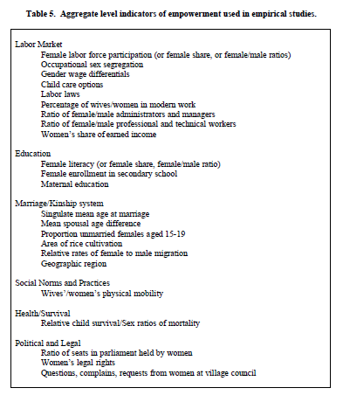**Appendix 2: Aggregate level indicators of empowerment used in empirical studies (Malhotra et al., 2002)**

**Appendix 3: Relationship between Outcomes and Correlates of Empowerment (World Bank, 2007)**



**Appendix 3 bis: Empowerment matrix: summary of analytic framework (World Bank, 2007)**



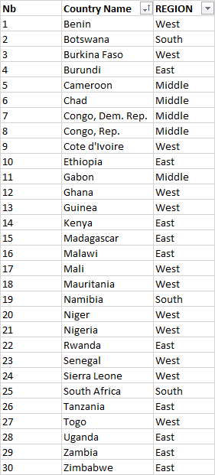**Appendix 4: List of the 30 Sub-Saharan African countries selected with the split by region**

**Appendix 5: “Mobile account” and “Mobile account female” variables (screenshot)**

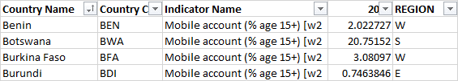

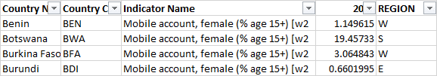

**Appendix 6: “Payments index” (screenshot)**

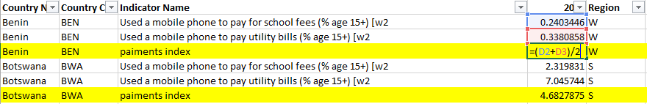

**Appendix 7: “Payments index female” (screenshot)**

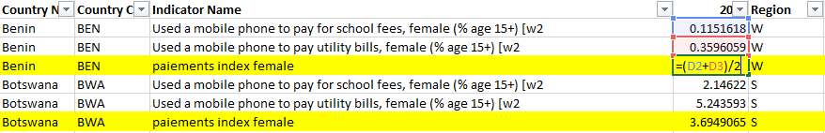

**Appendix 8: “Usages index” (screenshot)**

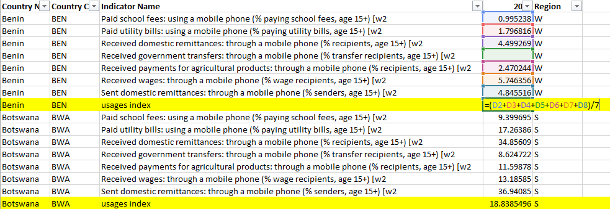

**Appendix 9: Construction of the geometric mean (screenshot)**

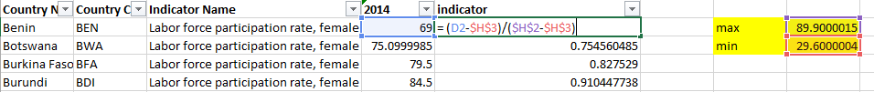

**Appendix 10: Women empowerment index (screenshot)**

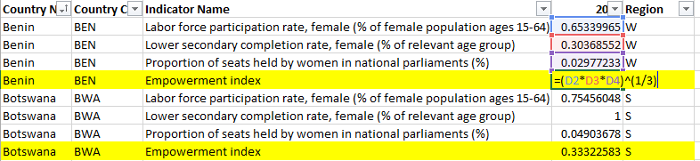

**Appendix 11: Mobile money variables correlation coefficients (screenshot)**

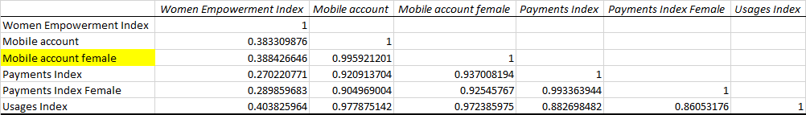

**Appendix 12: Control variables correlation coefficients (screenshot)**

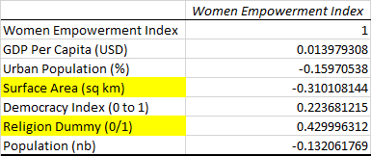

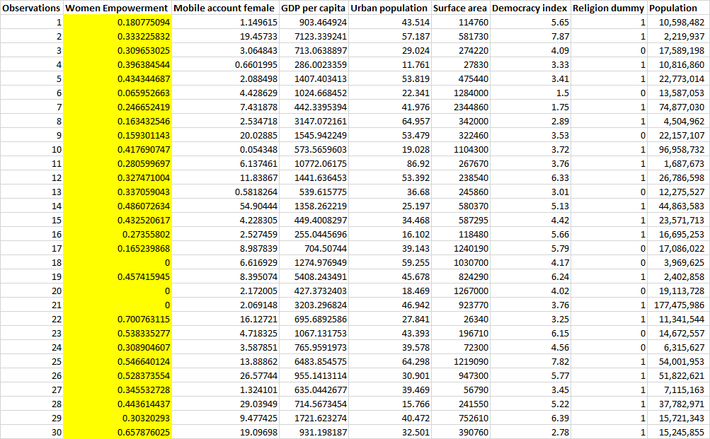**Appendix 13: Dataset used for the regression analysis**

**Appendix 14: Different steps of the forward analysis (screenshots)**

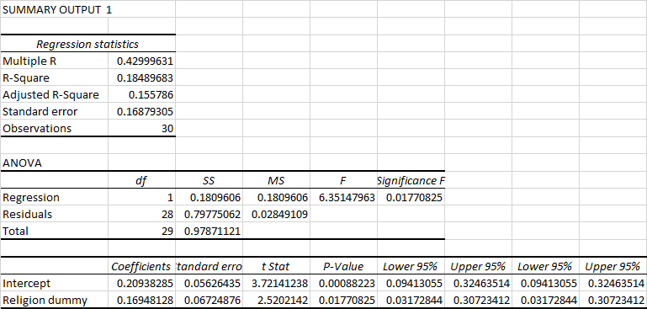

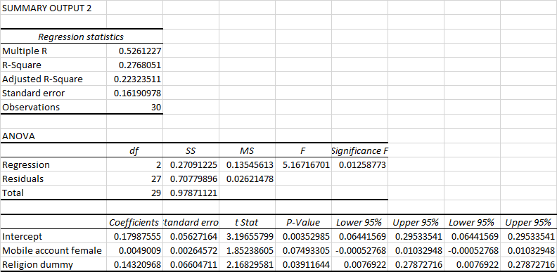

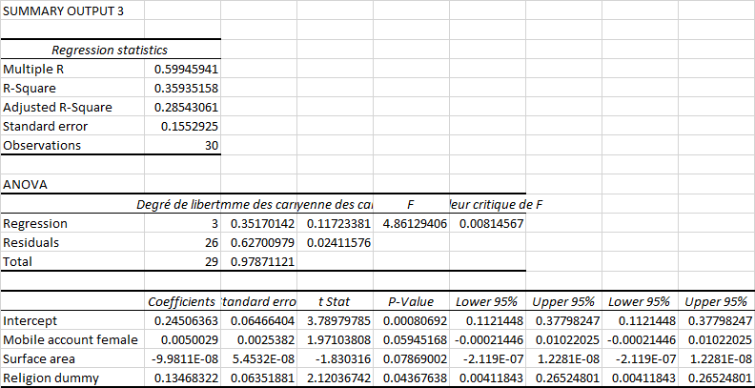

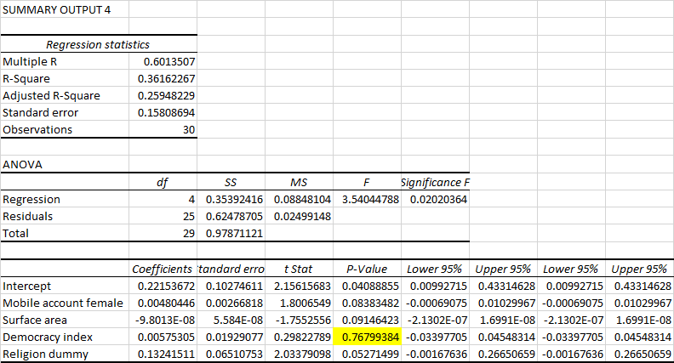

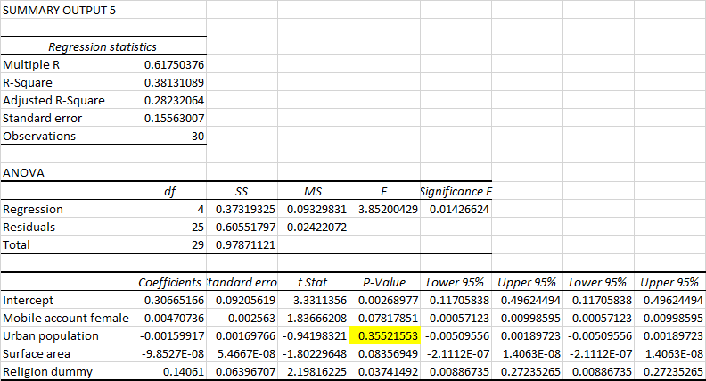

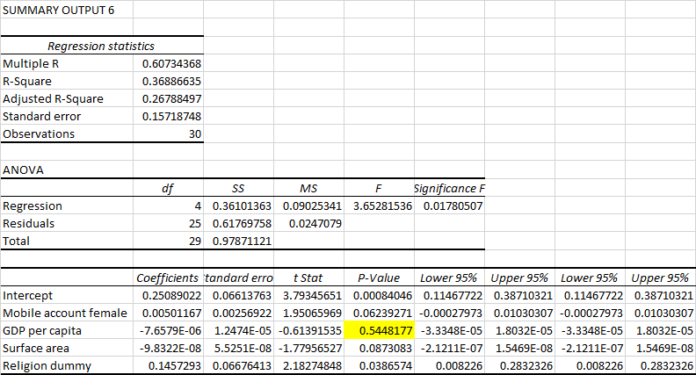

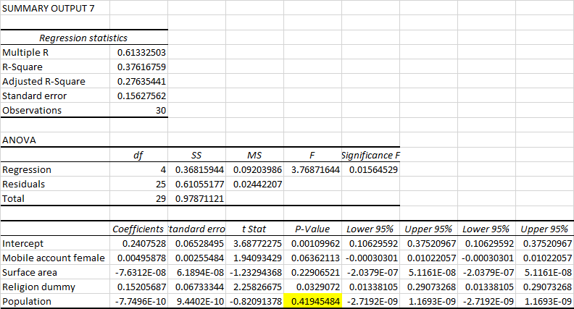

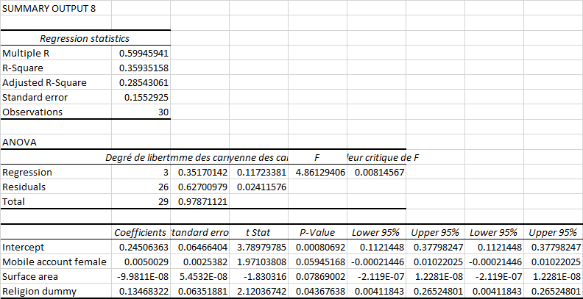

**Appendix 15: Different steps of the backward analysis (screenshots)**

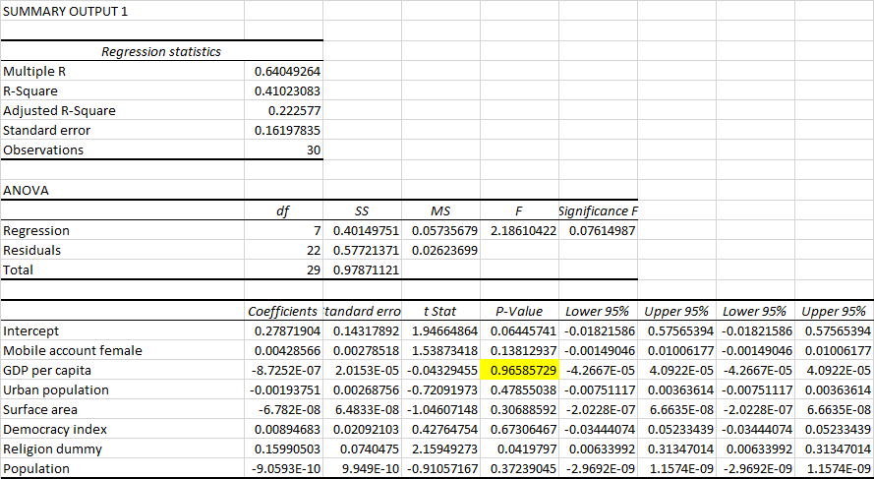

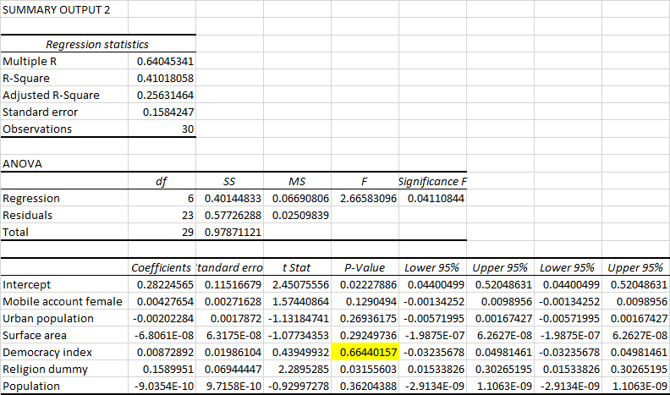

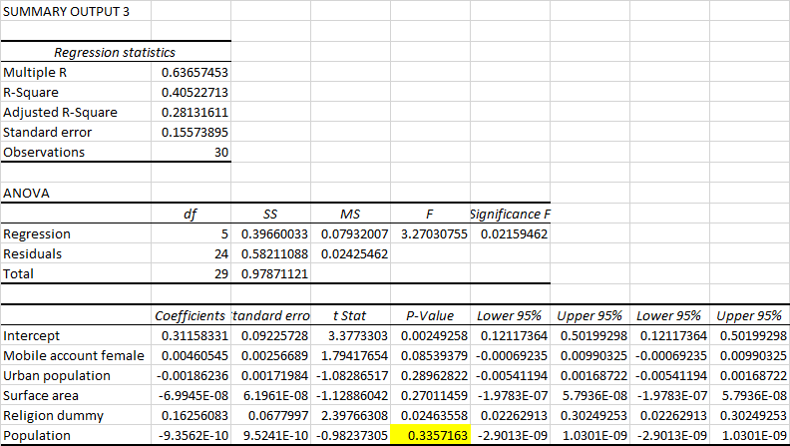

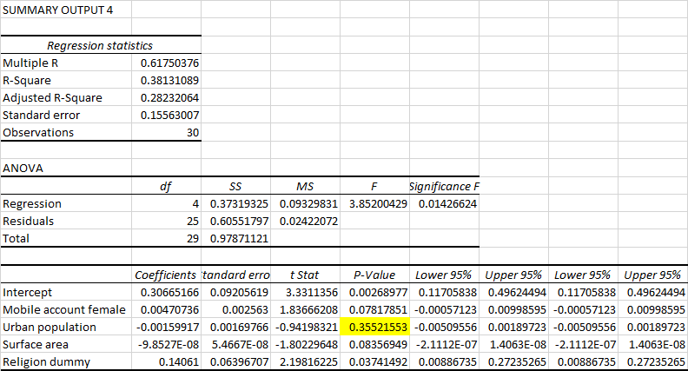

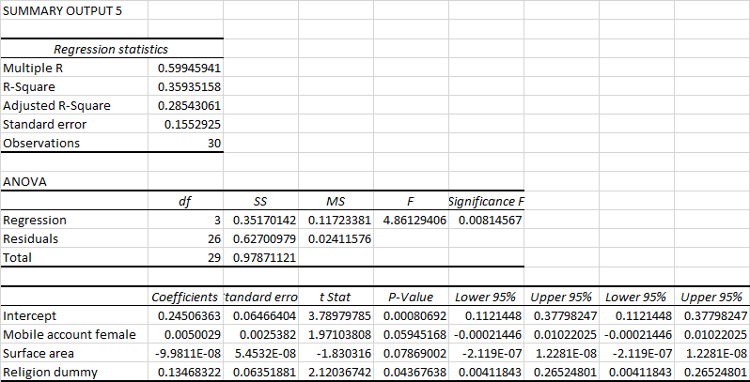

s